09th February 2022

Year 7 Parents/Carer Evening (SchoolCloud)

Dear Parents and Carers,
I am pleased to inform you that our Year 7 Parents/Carer Evening will take place on Thursday 17th February 4:00pm – 7:00pm via SchoolCloud.
SchoolCloud is a virtual system whereby parents/carers can book individual appointments with each of their child’s classroom teachers throughout the evening. SchoolCloud is accessible on any electronic device including a laptop, smartphone, or tablet. For the best experience, please ensure that the device you are using on the evening has a working camera and microphone.
This is our first opportunity to talk to you about your child’s academic progress since joining us at Brightstowe, and therefore, we cannot emphasise enough the importance of attending this event.
We sincerely hope that all parents/carers will be in attendance, however if it is the case that due to exceptional circumstances parent/carers are unable to attend, please do let Mr Stewart know via email in advance (david.stewart@oasisbrightstowe.org).
Appointments for Parents’ Evening can be made now and the appointment booking system will be live up until 15:00pm on 17th February 2022. Please visit our SchoolCloud website to book your appointments - https://oasisbrightstowe.schoolcloud.co.uk
A short guide on how to book appointments is included with this letter. The verification details (title, name, surname, child’s DOB) that you will be asked to provide to access your account will need to be an exact match to those that are held on our system.
If you have any queries regarding the use of SchoolCloud or have trouble with operating the system, please do contact our reception (hello@oasisbrightstowe.org) for assistance.
Yours sincerely,
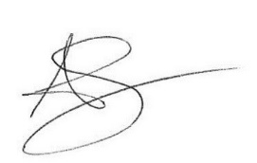
Andy Symes
Assistant Principal

