OCL Art Curriculum: Statement of Intent

Purpose of study
The visual arts make a vital contribution to children’s development in many ways both explicitly and implicitly. To understand visual culture is to be able to access the world in which we live. To practice Art presents students with the opportunity to learn and develop creative skills and techniques with different materials and processes discovering confidence and channels of self-expression. We study Art to inspire that personal expression, foster curiosity of the world around us and explore the limitless capabilities of our imagination whilst engaging with different cultures, historical events as well as providing opportunities to question, critique and make decisions. Our Art curriculum enables our young people to work independently, work collaboratively, develop resilience, problem solve, manage time and resources and ask the big questions; encouraging them to become thinkers, researchers, observers, makers and creators.

At Brightstowe we develop creativity by allowing students to be inspired, imaginative and independent. We want students to work like artists/photographers. Allowing themselves to be creative, inspired and passionate about their ideas. Students will be encouraged to experiment and learn from mistakes, understanding that this is a part of learning. Students will develop their independence to trust their own ideas and challenge themselves. We will focus on helping the students develop practical artistic skills, working with different materials and techniques. They will develop personal responses responding to the work of artists, crafts people and designers. Throughout their time with us the students will learn to trust their instincts by selecting images and materials they prefer, as well as exploring their ideas imaginatively. They will develop opinions about their own and artists work, as well as discovering different ways of working.
We value character, competence and community in our curriculum:
Competence: Developing student’s ability to use accurately and expressively a variety of skills, techniques and materials with confidence. Enabling them to make well-informed, good choices about their work and to understand and formulate connections between their work and the work of others. Being able to create a personal response through practice and understanding context: nurturing creativity

Character: Engaging all students in learning about visual culture that develops personal creativity, resilience, the willingness to take appropriate risks and the confidence to express feelings, thoughts and ideas: developing a sense of self. Confidently experimenting and exploring ideas and ways of working, being open to asking questions and challenging accepted ideas: developing a sense of wider responsibility. Thoughtfully investigating ideas of equality and diversity: developing a sense of inclusivity

Community: Inspiring students to develop a lifelong love, appreciation and understanding of a wide range of creative styles, traditions and contexts through considering the place of visual communication in their world. Improving health and wellbeing of themselves and others through their practice and through sharing their practice in different ways. Contributing to their futures though actively working sustainably and considerately of and for others: promoting ambition

Core concepts and principles of progression
The Oasis Art curriculum is planned carefully so that core art, craft and design skills, knowledge and understanding are developed over time. Expertise develops through consistent, deliberate practice from a solid foundation and immersion in the rich heritage of artistic and global, cultural traditions and movements.
#2 Artists follow (and break) rules: Artists learn the ‘rules’ and conventions so they can decide when and how to break them. Some artists work within established traditions and genres; others tease and disrupt these in alternative ways. Definitions of art are always changing. We learn the ‘rules’ by practicing accuracy, control and fluency in order to experiment and explore with purpose

#3 Artists play with ideas, materials and failure: Artists take creative journeys exploring materials, ideas and ways of working. Art is a process. Serendipitous outcomes can emerge through purposeful experimentation. Artists take risks and trust their intuition. We learn to be creative by creating. Embracing ‘happy accidents’ and learning from ‘mistakes’. We are ‘creative apprentices’ learning habits, routines, methods and questioning – understanding our motivations to create our own work with increasing independence and skill

#4 Art has its own language: Artists learn a vocabulary in the same way that we learn language through imitation, practice and study of structure. Art narrates an experience or documents an event. Art and design use symbols as a short hand and create reference points through physical and implied connections. Art is an international language, which references culture and identity and our ability to interpret and create relies on our understanding of this language. We learn how to decode and encode works through progressive practice in identifying, deciphering and interpreting to enable us to apply, exploit and manipulate this language through our own responses

#1 Artists tell stories: Works of art, craft, design and architecture consist of formal elements and principles of design (such as line, shape, form, pattern, texture, colour and balance, rhythm, contrast etc.). These elements combine to communicate in many ways, often suggestive of histories and traditions. From ancient times, artists have used these elements in different ways over time to tell their own stories in response to the world in which they are or have been a part. The histories of art - the stories we share about art and artists - are also subject to change across time and space. We learn to tell our own stories through developing our practice with the formal elements as our foundation – what we see and later what we know and what we think and feel

#5 Art engages – me and you: Art stimulates the mind and body – perception and cognition/conscious and unconscious feeling. Artists use their heads, hands and hearts during the creative process. To engage with a work of art a viewer may form opinion from an aesthetic perspective or might also physically employ their senses. Art can evoke a heightened sense of place and wonder. We can immerse ourselves in the act of creating; art can be physically and mentally restorative. We learn to look at, share and create work of increasing complexity and purpose, processing information and developing a personal response to stimulus

#6 Artists ask questions: Artists challenge ideas of what has gone before by asking questions of themselves and of their audience. By using the see, know, think model with increasing levels of sophistication across the learning pathway, pupils are equipped to investigate aesthetics and meaning in their work and the work of others. We learn to ask questions through mindful practice of looking at (our) art and pushing our artistic boundaries to help inform our practice and form opinions with increasing discrimination

#8 Art is not fixed in meaning – context is everything: Artists have intentions when creating work but what the viewer understands may be different. Individual interpretations of art are rarely the same but shaped by knowledge, personal experience, prejudice and time. The same work takes on new meaning if the parameters change; history is rarely fixed - new discoveries and perspectives can radically alter what might have previously seemed secure. Art does not only change the way we look at things, it can influence the way we recall the past and imagine the future. Artworks exist as evidence of purposeful action by an artist within a particular time and place. Awareness of this context - when, where, by whom, and why - can influence the meaning that a viewer draws from the work. How does an artwork become so... well-known, famous, infamous, notorious, iconic, ironic, sought-after, hated, expensive, precious, devalued, boring…? We learn about works of art across time by experiencing and observing how the use of materials, processes, subject matter and events relate to our work. We consider how global connections, culture and heritage influence, shape and describe our understanding of art ‘his’tory and our own creations
#7 Art has value in unequal measure: The value of art is measured by society in different ways - personal, cultural, social, economic, political, historical. Works of art and artists are not equally valued and attitudes to art change over time. Artists and ideas in art can be marginalised because of prevailing social attitudes. We learn to challenge preconceived notions of art and its documentation of histories by asking questions, considering our own aesthetic perspectives and preferences and developing understanding of the ability of art to illuminate and enrich our experience, building confidence over time to express and articulate our thinking in different ways

#10 Art is contradictory and complex*: the concept of art has significantly shifted over its history. New views of art have emerged to challenge the old, complicating though not erasing what has gone before. Artists understand the branches of art practice: traditional, modern and contemporary and the impact that history, heritage and metamorphosis has on aesthetic and meaning. Each idea of art has its distinctive values and characteristics. We learn to deconstruct and reconstruct ideas and methodologies to foster connection and innovation. We develop technical skill enabling us to become adept at personal, creative expression
*See Fig 1.

#9 Art is powerful: Art has the potential to influence human behaviour. It can evoke emotion and provoke action, shaping the world by changing opinions, instilling values and translating experiences. It allows people from different cultures and times to communicate with each other. Art empowers us to notice, question, interact and respond. It is a way of understanding and expressing our existence. Historically a way of demonstrating power and wealth, art can be used to excite and incite. We learn to understand the meaning, purpose and power of works of art and design through time and culture and translate that in to our own work. We move from thinking to doing – learning to make conscious choices and decisions about our work and how we want it to be perceived

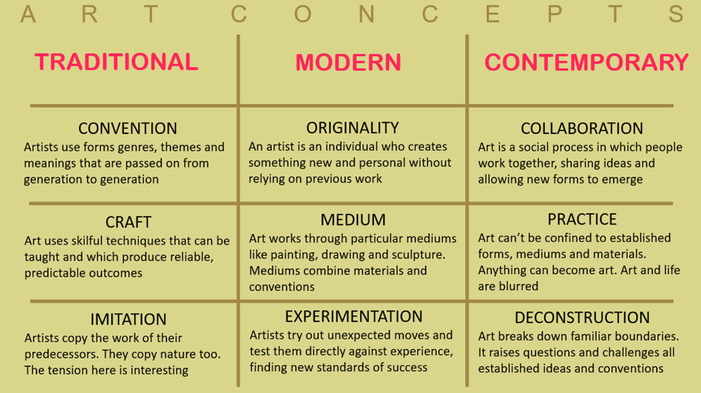
*Fig.1
Neil Walton, Subject Leader for PGCE Art & Design at Goldsmiths, University of London

Aims/outcomes
Through our carefully sequenced and ambitious curriculum, we intend that our curriculum will achieve these aims/outcomes:
1. To equip all students with the knowledge, skills and understanding so that they will know how to make art, craft and design successfully, being able to:
- Use a wide range of materials, processes and techniques with confidence
- Use a wide range of materials, processes and techniques with skill and accuracy
- Work in 2D
- Work in 3D
- Create their own works of art; devising, developing and executing a personal response
- Understand the process of creating their own work
- Develop and use primary sources for personal work
- Identify, explore and use the elements of art and design within their own work
- Review and refine work independently

2. To build the foundation for all students to decode and encode visual language, its history and context:
- Understand and use art language both in creating visual work and in thinking and writing about the work of others
- Be able to articulate their reasons for choices and decisions they have made
- Rigorously question, observe, identify, dissect, analyse, evaluate and use ideas from art across the full range of historical periods, genres, cultures and traditions, including the works of architecture, photography, craft and design (*see Fig. 2)
- Broaden and deepen essential world knowledge and use this to create purpose in their work
- Use a wide range of materials, processes and techniques with purpose to convey meaning, realising intentions
- Think in abstract ways from concrete starting points making connections between their work and the work of others
- Work with professionals from a range of disciplines
- Have opportunities to visit galleries and exhibitions and view art in different contexts
- Have opportunities to study art and artists with particular local, contextual significance

3. To enable all students to develop their character, confidence and identity through practising art, evidenced by being able to:
- Resilience to rehearse, improve, create, embrace success and the unplanned, give and take feedback and become reflective practitioners
- Empathy, sensitivity, understanding and openness to others
- Take appropriate risks and demonstrate good decision making skills with materials, resources, ideas and ways of working
- Problem solve with enthusiasm – think creatively around a situation or piece of work
- Demonstrate confidence, collaboration and leadership skills
- Engage in extra-curricular events and enrichment activities that allow them to develop their own interests and means to express themselves
- Take advantage of opportunities such as competitions or community events to demonstrate creative skills
- Understand the role of art in shaping individuals, culture and community for good
- Celebrate diverse backgrounds, values and characteristics in their work
- Develop their own values and sense of identity through their work
- Demonstrate understanding of people with different beliefs and perspectives
- Challenge stereotypes

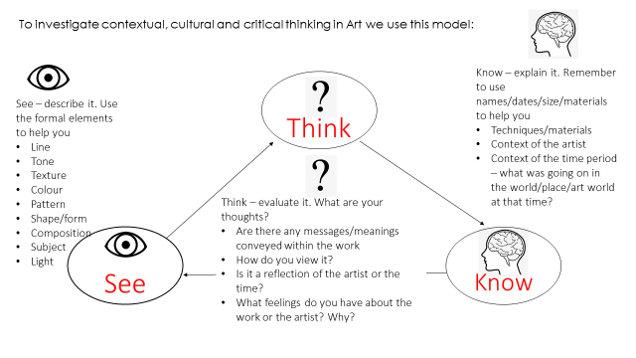

*Fig.2
A model developed to aid students in decoding a work of art

