The Challenge of Resource Management Page 27
Question | A B C
- State three essential resources. |  | Food, water, energy | Food, coal, energy | Minerals, water, energy
- Where in the world is there a food surplus and food deficit? |  | USA | Chad | India
- Identify a cause of water surplus? |  | Low rainfall | High rainfall | Impermeable rocks
- Identify a cause of water deficit. |  | Low rainfall | High rainfall | Impermeable rocks
- Identify one reason why NEEs use more energy than LICs. |  | They have fewer household appliances | The have more factories that use energy | They have fewer factories that use energy
- How much of the UKs food is imported? |  | 40% | 50% | 60%
- State one reason the UKs food is imported. |  | Increased demand for exotic fruits (mangoes) | Food is more expensive to grow abroad | There is no longer a demand for seasonal food all year round.
- Identify a negative impact of importing food? |  | Increased food miles = higher carbon foot print | Increased food miles = lower carbon foot print | Decreased food miles = higher carbon foot print
- What is organic farming? |  | Farming that uses lots of chemicals It is usually large scale. | Intensive large scale farming that uses machinery and chemicals. | Farming that does not use chemicals. It is usually small scale.
- Give one disadvantage of organic farming. |  | Products are affected by the high use of chemicals used during farming. | Products are often more expensive than crops grown in large scale farms. | Products are often less expensive than crops grown in large scale farms.
- What is agribusiness? |  | Large scale intensive farms that do not use machinery | Small scale farms that don’t use chemicals. | Large scale intensive farms that use lots of machinery.
- How has agribusiness decreased food miles? |  | More food is produced in the UK. As a result less is imported. | Farms often are located next to the supermarket they are being sold in. | Less food is produced in the UK. As a result, more is imported.
- Why has water use in the UK increased? |  | Factories are using less water than previously. | As incomes increase, more household appliances are used the use lots of water | As the population has increased, people wash less often.
- Why is there a water deficit in south-east England? |  | Low population and high rainfall | High population and high rainfall. | High population and low rainfall.
- Why is there a water surplus in central Scotland? |  | Low population and high rainfall | High population and high rainfall. | High population and low rainfall.
- What is a water transfer scheme? |  | When water is transferred from an area of water deficit to an area of water surplus. | When water is transferred from an area of water surplus to an area of water deficit. | When water is transferred from an area of water surplus to an area of water surplus.
- Identify how much of the UKs water is clean. |  | 27% | 17% | 37%
- State one way factories contribute to water pollution. |  | Pesticides and fertilizers contaminate water in farms. | Toxic waste from factories is released into rivers. | Oil from cars gets into rivers = pollution.
- State how agriculture causes water pollution. |  | Pesticides and fertilizers contaminate water in farms and causes eutrophication. | Toxic waste from factories is released into rivers. | Oil from cars gets into rivers = pollution.
- What is the role of a water treatment plants? |  | To improve sewage works (e.g. Tideway Project) | To control waste production and disposal. | To remove bacteria, algae and chemicals from water.
- Why is chlorine added to water supplies? |  | To remove bacteria | To remove pesticides | To remove acid
- How will the Tideway Project improve water quality? |  | It prevents sewage flowing into the River Thames | It prevents pesticides and fertilizers contaminating the River Thames | It prevents toxic waste from factories flowing into the River Thames
- What is the UK’s energy mix? |  | Fossil fuels and nuclear power | Fossil fuels, nuclear power and renewable energies | Fossil fuels and renewable energies
- State how much of the UKs energy is powered by renewables. |  | 24.7% | 34.7% | 14.7%
- How many coal fields are open in the UK? |  | 5 | 0 | 10
- Why are less fossil fuels used today? |  | The EU fines companies who release too many greenhouse gases. | 25% of oil and gas reserves are gone. | 80% of coal fields are closed down.
- State one reason why fossil fuels will continue to be used in the future. |  | Fossil fuels are cheap to import. | The infrastructure for renewable energy is cheap to build. | We have enough fossil fuels to provide the UK with energy for hundreds of years.
- Give one economic impact of using fossil fuels. |  | The cost of drilling oil in the North Sea is expensive | Fossil fuels release greenhouse gases | Coal mines require land to be cleared = habitat loss.
- Give one environmental impact of using fossil fuels. |  | Coal must now be imported from South Africa, which is expensive | The cost of drilling oil in the North Sea is expensive | Fossil fuels release greenhouse gases
- Give one economic impact of using renewable energies. |  | New infrastructure is expensive to build. | Wind turbines cause noise pollution | Solar panels cause visual pollution
- Give one environmental impact of using renewable energy. |  | New infrastructure is expensive to build. | Wind turbines cause noise pollution | Renewable energies are unreliable = sometimes energy must be brought from other sources if there isn’t enough.
- Give one economic impact of using nuclear power. |  | Radioactive waste must be stored very carefully, which is expensive. | Radioactive leaks can harm local wildlife. | Warm waste water from nuclear power stations can harm local ecosystems.
- Give one environmental impact of using nuclear power. |  | Radioactive waste must be stored very carefully, which is expensive. | Nuclear power stations are very expensive to build. | Radioactive leaks can harm local wildlife.

The Challenge of Resource Management Page 27
Question
- State three essential resources.
- Where in the world is there a food surplus and food deficit?
- Identify a cause of water surplus?
- Identify a cause of water deficit.
- Identify one reason why NEEs use more energy than LICs.
- How much of the UKs food is imported?
- State one reason the UKs food is imported.
- Identify a negative impact of importing food?
- What is organic farming?
- Give one disadvantage of organic farming.
- What is agribusiness?
- How has agribusiness decreased food miles?
- Why has water use in the UK increased?
- Why is there a water deficit in south-east England?
- Why is there a water surplus in central Scotland?
- What is a water transfer scheme?
- Identify how much of the UKs water is clean.
- State one way factories contribute to water pollution.
- State how agriculture causes water pollution.
- What is the role of a water treatment plants?
- Why is chlorine added to water supplies?
- How will the Tideway Project improve water quality?
- What is the UK’s energy mix?
- State how much of the UKs energy is powered by renewables.
- How many coal fields are open in the UK?
- Why are less fossil fuels used today?
- State one reason why fossil fuels will continue to be used in the future.
- Give one economic impact of using fossil fuels.
- Give one environmental impact of using fossil fuels.
- Give one economic impact of using fossil renewable energies.
- Give one environmental impact of using renewable energy.
- Give one economic impact of using nuclear power.
- Give one environmental impact of using nuclear power.

THE CHALLENGE OF RESOURCE MANAGEMENT PART 1 (page 27)

Three of the world’s essential resources are food, water and energy. Choose of these and explain why they are considered essential. (4 marks)

Study Figure 1 and 2, information about fracking for gas in the UK.
- Suggest one reason for the development of fracking in the UK. (1 mark)
- Using Figure 2, describe the distribution of areas with existing licences for fracking in the UK. (2 marks)
- With the help of Figures 1 and 2, explain why the process of fracking for gas causes conflict between different groups of people. (6 marks)

Study Figure 3, a sign in a farm shop in Lincolnshire and 4, a map
- What are food miles? (2 marks)
- What does Figure 3 suggest about the food miles of items sold in this shop? (2 marks)
- Explain the benefits of the increasing use of locally produced foods. (4 marks)
- Use Figures 3 and 4 to describe the source area of the food for sale in this farm shop (2 marks)
- Explain the benefits of the increasing use of locally produced food. (4 marks)

Explain how the demands of supermarkets and food processing firms affect farming? (4 marks)

Study Figure 5, a list of some features of modern farming methods.
- What is agri-business?
- Using the figure and your own knowledge describe how modern farming can impact on the environment. (4 marks)
- Explain how the negative environmental effects of these features may be reduced. (4 marks)

Commercial farming in the UK has been influenced by a number of factors, such as the demands of supermarkets and competition from the global market. Use a case study to describe the effects of one or both of these factors on commercial farming in the UK. (8 marks)

Outline the role of a water transfer scheme. (2 marks)

Only 27% of the UK’s water is classified as ‘clean’. Suggest two reasons for this. (4 marks)
Describe the strategies used in the UK to improve water quality. (6 marks)

The UK’s current energy mix is: 52.6% fossil fuels, 21% nuclear power and 24.7% renewable energies. Suggest how and why this will likely change in the future. (6 marks)

Discuss the economic and environmental impacts of using fossil fuels, renewable energies and nuclear power. (9 marks)

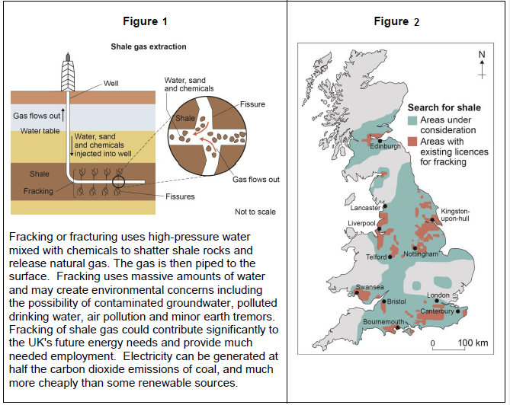

Figure 3 Figure 4
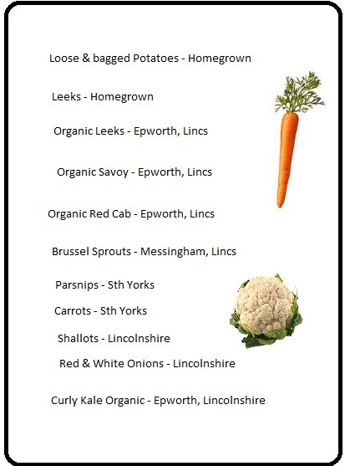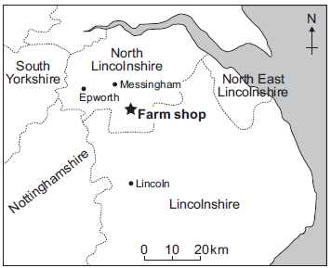

Figure 5

The Challenge of Resource Management Page 28
Question | A B C
- Define food security |  | When a population has access to enough affordable, nutritious food to maintain a healthy lifestyle. | When a population does not have access to enough affordable, nutritious food to maintain a healthy lifestyle. | When a population has access to enough expensive nutritious food to maintain a healthy lifestyle.
- Define food insecurity |  | When a population does not have access to enough safe affordable and nutritious food. | When a population has access to enough affordable, nutritious food. | When a population has access to enough expensive nutritious food.
- Define undernourishment |  | A poor diet with a lack of nutrients | A good died with lots of nutrients | A balanced diet
- List one reason India has high food supply? |  | They have lots of investment of machinery. | They have a large population. | They are an HIC.
CAUSES OF FOOD SURPLUS/FOOD DEFICIT
- How does climate affect food supply? |  | If there is too much or too little rain, crops are destroyed. | If there is unreliable rainfall crops grow very well | If there are too many pests, crops are destroyed.
- How does pests and diseases affect food supply? |  | HICs often have a warmer climate = lots of pests that destroy crops. | LICs often have a warmer climate = lots of pests that destroy crops. | If there is too much or too little rain, crops are destroyed.
- How does conflict affect food supply? |  | During wars there is often a food deficit, as men are fighting instead of farming. | During wars, there is often a food surplus because men are working on the fields instead of fighting | During war there is often a food deficit because the government ensure all people have enough food
- How does poverty affect food supply? |  | LICs do not have the money to invest in seeds, fertilizers or irrigation. As a result, there is often a food deficit. | HICs have the money to invest in seeds, fertilizers or irrigation. As a result, there is often a food deficit. | LICs do not have the money to invest in seeds, fertilizers or irrigation. As a result, there is often a food surplus.
- Identify a physical cause of food deficit |  | Climate | Technology | Poverty
- Identify a human cause of food surplus. |  | Poverty | Climate | Pests & Diseases
IMPACTS OF FOOD INSECURITY
- Define famine |  | The lack of a balanced diet | The shortage of food due to conflict. | The widespread shortage of food.
- How many people died of famine in Somalia? |  | 258,000 | 228,000 | 208,000
- Food insecurity results in food riots. What is an example? |  | Algeria, 2011 | Egypt, 2011 | Chad, 2011
- Why does food insecurity result in food riots? |  | If there is an excess of food, people fight over the available food. | If there is a shortage of food, people calmly distribute it between the people | If there is a shortage of food, people fight over the available food.
- Identify one environmental impact of food insecurity. |  | Soil erosion | Food riots | Famine
EXAMPLE OF A LARGE SCALE AGRICULURAL DEVELOPMENT: THANET EARTH
- How many greenhouses are at Thanet Earth? |  | 1 | 3 | 5
- How do they ensure long growing seasons? |  | Natural light and hydroponics | Artificial lighting and hydroponics | Artificial lighting and aeroponics.
- How do they recycle water? |  | Recycle water from local homes (greywater) | Collect rainwater in 7 onsite reservoirs | Collect water in 1000 harvesting tanks.
- Each greenhouse has its own power station providing its energy. What do they do with the waste products (carbon dioxide&heat)? |  | It is pumped back into the greenhouses to help the plants grow. | It is pumped into the atmosphere. | It is pumped deep underground.
- State two advantages of Thanet Earth |  | Provides 500 jobs | More food grown in the UK = less imported = less food miles. | Artificial light = visual pollution
- State two disadvantages of Thanet Earth |  | Habitats are disrupted as the large area of green farmland was used. | Natural predators are used = less chemicals used. | A large area of green farmland was built on = loss of habitats and wildlife
- Identify one environmental benefit of Thanet Earth |  | Natural predators are used = less chemicals used. | Provides 500 jobs | Artificial light = visual pollution
- Identify one social benefit of Thanet Earth |  | Natural predators are used = less chemicals used. | Provides 500 jobs | Artificial light = visual pollution
- Identify one environmental disadvantage of Thanet Earth. |  | Energy is used to package and transport food = release of greenhouse gases | Money goes to large companies rather than local communities | Artificial light = visual pollution

The Challenge of Resource Management Page 28
Question
- Define food security
- Define food insecurity
- Define undernourishment
- List one reason India has high food supply?
CAUSES OF FOOD SURPLUS/FOOD DEFICIT
- How does climate affect food supply?
- How does pests and diseases affect food supply?
- How does conflict affect food supply?
- How does poverty affect food supply?
- Identify a physical cause of food deficit
- Identify a human cause of food surplus.
IMPACTS OF FOOD INSECURITY
- Define famine
- How many people died of famine in Somalia?
- Food insecurity results in food riots. What is an example?
- Why does food insecurity result in food riots?
- Identify one environmental impact of food insecurity.
EXAMPLE OF A LARGE SCALE AGRICULURAL DEVELOPMENT: THANET EARTH
- How many greenhouses are at Thanet Earth?
- How do they ensure long growing seasons?
- How do they recycle water?
- Each greenhouse has its own power station providing its energy. What do they do with the waste products (carbon dioxide&heat)?
- State two advantages of Thanet Earth
- State two disadvantages of Thanet Earth
- Identify one environmental benefit of Thanet Earth
- Identify one social benefit of Thanet Earth
- Identify one environmental disadvantage of Thanet Earth.

THE CHALLENGE OF RESOURCE MANAGEMENT PART 2 (page 28)

Study Figure 1, a map showing the percentage of population that was undernourished in Africa in 2014.
- What percentage of the population was undernourished in Chad in 2014: 5-14.9%, 14-24.9%, 25-35% or more than 35%? (1 mark)
- Using the map, describe the distribution of countries in Africa where there are high and very high levels of undernourishment. (2 marks)

Describe the physical causes of food insecurity. (4 marks)
Describe the human causes of food insecurity. (4 marks)

Study Figure 2, a list of some of the impacts caused by changing from subsistence farming to growing cash crops.
- What is ‘subsistence farming’?
- State one way in which cash crop farming is different from subsistence farming. (1 mark)
- Suggest how a poorer country can benefit from producing cash crops. (2 marks)
- Using Figure 1 and your own knowledge, explain how these impacts are caused by the change to cash crops. (4 marks)

There are many impacts of soil erosion in sub-tropical and tropical areas. Decide whether each of the following impacts is environmental or economic: (3 marks)
- Loss of habitats
- Lower crop yields
- Lower biodiversity

Suggest how food deficit can cause social and environmental problems. (6 marks)

Describe the main features of a large scale agricultural development project you have studied. (4 marks)

How far do large scale agricultural development projects benefit an area. Use a case study and your own information. (9 marks)

Figure 1

Figure 2

The Challenge of Resource Management Page 29
INCREASING FOOD SUPPLY | A | B | C
- What is the green revolution? | A strategy to decrease food supply by using high yielding varieties and chemicals. | A strategy to increase food supply by using high yielding varieties and chemicals. | A strategy to increase food supply by using irrigation and hydroponics.
- When did the green revolution start? | 1960s | 1970s | 1980s
- Why did the green revolution fail? | It produced too much food for the rising population | It was too harmful to the environment | It did not produce enough food for the rising population
- When did the new green revolution start? | After the green revolution failed | Before the green revolution failed | At the same time as the green revolution
- Identify two strategies used in the new green revolution to increase food supply. | Use of GM crops | Use of irrigation schemes | Use of inappropriate technology
- What is hydroponics? | The artificial watering of crops | Plants are grown in a nutrient rich water | Plants are suspended in the air and their roots sprayed with nutrient water.
- What is aeroponics? | The artificial watering of crops | Plants are grown in a nutrient rich water | Plants are suspended in the air and their roots sprayed with nutrient water.
- Identify one benefit of using hydroponics or aeroponics. | The plants received the perfect amount of nutrients, fertilizers and light = all crops healthy | It requires expert knowledge and be expensive to use. | It can cause salinization
- Is it appropriate for HICs or LICs ? | HICs | -- | LICs
- What is irrigation? | The artificial watering of crops | Plants are grown in a nutrient rich water | Plants are suspended in the air and their roots sprayed with nutrient water.
- Define drip irrigation | Plants are watered where the plants roots are. | The whole field is flooded | A sprinkler sprays water on the crops
- Suggest another example of irrigation. | Sprinklers | Hydroponics | Urban farming
- How does irrigation cause salinisation? | Water sinks into the soil and washes away nutrients | Water is slowly evaporated, leaving the salts behind on the soil | Water is quickly evaporated, leaving the salts behind on the soil
- What are GM crops? | Genetically modified crops to make them resistant to droughts. | Genetically modified crops to make them less resistant | Genetically modified crops to make them more resistant
- Suggest an example of GM crop. | Decrease the vitamins in crops | Resistant to pests | Resistant to sunlight
- State one location where GM maize is used | Philippines | UK | Chad
- Provide one disadvantage of using GM crops. | They can be expensive to use. | They are only used to create animal feed | They are resistant to all pests.
- Provide one advantage of using GM crops. | Less money is generated in agriculture | They can increase crop yields (more food) | They can increase crop yields (less food)
- What does appropriate technology mean? | The technology is appropriate for the country using it. (e.g. LICs – cheap and easy to use) | The technology is appropriate for the country using it. (e.g. LICs – expensive and easy to use) | The technology is appropriate for the country using it. (e.g. HICs – expensive and easy to use)
- Suggest an appropriate technology for a LIC. | Hydroponics | Biotechnology | Irrigation
INCREASING FOOD SUPPLY SUSTAINABLY
- What is organic farming? | Farming that uses lots of chemicals It is usually large scale. | Intensive large scale farming that uses machinery and chemicals. | Farming that does not use chemicals. It is usually small scale.
- Suggest one reason why organic farming is sustainable. | Rainwater is collected and reused. | Pests are kept away using pesticides. | Soil is kept fertile using fertilizers
- What is urban farming? | Gardens are created on unused land in rural areas | -- | Gardens are created on unused land in urban areas
- Give one environmental advantage of urban farming. | Food doesn’t travel far from the farm where it is grown to where it is sold | People can make money from the food they grow. | It gives people hobbies
- What does reduce food waste mean? | Increasing the amount of food that is thrown away. | Reducing the amount of food that is thrown away. | --
- Suggest one way reducing food waste will increase food supply. | If more food is thrown away, there is less food available. | If less food is thrown away, there is less food available. | If less food is thrown away, there is more food available.
- Identify two characteristics of a sustainable source of meat and fish | Lack of chemicals and machinery | Small scale | Large scale
- Why should people not buy food from large scale intensive fish and meat farms? | They make lots of money | They harm the environment | They do not employ as many people
A LOCAL SCHEME TO INCREASE FOOD SUPPLY SUSTAINABLY: THE MAKUENI & WATER SECURITY PROGRAME.
- Locate Makueni | South Kenya | North Kenya | East Kenya
- Why was there food insecurity in Makueni? | Low population and high rainfall | High population and low rainfall | High population and high rainfall
- What charity teamed up with the African Sand Dam Foundation in 2004? | Just a Drop | WaterAid | ActionAid
- What three things did they do to increase food supply? | Build a water harvesting tank, water dam and afforestation | Build a water harvesting tank, sand dam and afforestation | Build a water harvesting tank, sand dam and deforestation
- What is a sand dam? | A concrete wall built across a river channel. This traps sediment carried in water flowing downstream. The sand builds up and stores water. | A water transfer scheme. Water is moved from areas of water surplus to areas of water deficit. | A water pipe that goes into the desert. This water pipe carries water to areas that have very low water supply.
- Where is the water stored? | In water pipes | In the sand | In the lake
- Why is this type of water storage useful in Kenya? | The water cannot evaporate as it is stored in the ground | The water is available to all the people who live in Kenya | It provides jobs to the locals.
- Identify two ways it helped the people in Makueni. | Crop yields increased due to increased water supply | Waterborne diseases increased due to the sand filtering the water. | Less time was wasted collecting water from far away streams.

The Challenge of Resource Management Page 29
INCREASING FOOD SUPPLY
- What is the green revolution?
- When did the green revolution start?
- Why did the green revolution fail?
- When did the new green revolution start?
- Identify two strategies used in the new green revolution to increase food supply.
- What is hydroponics?
- What is aeroponics?
- Identify one benefit of using hydroponics or aeroponics.
- Is it appropriate for HICs or LICs and why?
- What is irrigation?
- Define drip irrigation
- Describe another example of irrigation.
- How does irrigation cause salinisation?
- What are GM crops?
- Suggest an example of GM crop.
- State one location where GM maize is used
- Provide one disadvantage of using GM crops.
- Provide one advantage of using GM crops.
- What does appropriate technology mean?
- Suggest an appropriate technology for a LIC.
INCREASING FOOD SUPPLY SUSTAINABLY
- What is organic farming?
- Suggest one reason why organic farming is sustainable.
- What is urban farming?
- Give one environmental advantage of urban farming.
- What does reduce food waste mean?
- Suggest one way reducing food waste will increase food supply.
- Identify one characteristic of a sustainable source of meat.
- Identify one characteristic of a sustainable source of fish.
- Why should people not buy food from large scale intensive fish and meat farms?
A LOCAL SCHEME TO INCREASE FOOD SUPPLY SUSTAINABLY: THE MAKUENI & WATER SECURITY PROGRAME.
- Locate Makueni
- Why was there food insecurity in Makueni?
- What charity teamed up with the African Sand Dam Foundation in 2004?
- What three things did they do to increase food supply?
- What is a sand dam?
- Where is the water stored?
- Why is this type of water storage useful in Kenya?
- Identify two ways it helped the people in Makueni.

THE CHALLENGE OF RESOURCE MANAGEMENT PART 3 (page 29)

Figure 1 shows a list of impacts that are caused by using irrigation in farming.
- Using the figure and your own knowledge, describe how using irrigation can increase food supply. (4 marks)
- Using the figure and your own knowledge, describe how using irrigation can cause negative impacts in LICs and NEEs. (3 marks)

Explain how one or more agricultural changes have increased world food production. (4 marks)
Explain why trying to increase the amount of food produced in the world may have environmental disadvantages. (4 marks)

Using examples, describe how people are increasing food supply in LICs and NEEs. (6 marks)

What is meant by the term salinisation? (1 mark)
Explain the processes leading to salinisation. (4 marks)

Explain how the quantity of food produced can be increased. (6 marks)

Biotechnology, aeroponics and hydroponics are used to increase food supply. Assess the suitability and effectiveness of using these strategies. (9 marks)

Outline the main strategies used in the Green Revolution and New Green Revolution. (4 marks)

Study Figure 2, a graph showing the growth of the world’s population and of cereal production between 1950 and 2000.
- How much cereal was produced in 1990? (1 mark)
- What does the graph show about the changes in cereal production and world population between 1950 and 2000? (4 marks)

Should LICs, such as Kenya, invest in ‘high-tech’ or ‘low-tech’ methods of increasing food production? Justify your answer. (6 marks)

Suggest how a local scheme can increase food security in a LIC or NEE. (9 marks)

Urban farming and organic farming are two sustainable strategies to increase food supply.
- Suggest why they are considered sustainable. (4 marks)
- Describe a different sustainable strategy to increase food supply. (4 marks)

Figure 1
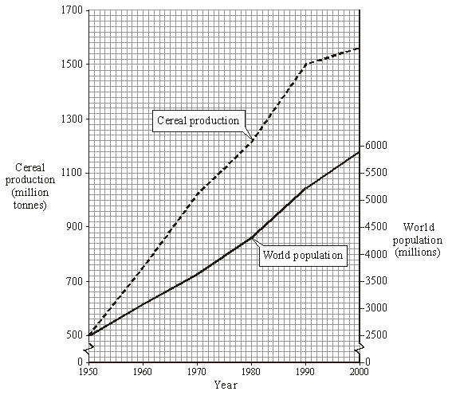

Figure 2

