The Challenge of Natural Hazards Page 1
Question | A B C
- Identify the four layers of the earth. |  | Mantle, outer crust, core, inner core | Mantle, inner core, crust, outer core | Mantle, inner crust, middle core, outer core
- Define tectonic plate |  | The central part of the core. | The crust that is made up of one massive rock. | The broken up pieces of rock that float on top of the mantle.
- There are 2 types of crust: continental and oceanic. Outline the key differences between these two crusts. |  | Oceanic crust is less dense, thinner and younger. | Oceanic crust is more dense, thinner and younger | Ocean crust is more dense, thicker and younger.
- What is a convection current? |  | A circular current in the inner core that causes the mantle to move. | A circular current in the mantle that causes the underlying core to move. | A circular current in the mantle that causes the overlying tectonic plates to move.
- What is the process of slab pull? |  | Heavy plates subduct at destructive plate margins. This pulls the rest of the plate with it = movement of tectonic plates. | Heavy plates subduct at collision plate margins. This pulls the rest of the plate with it = movement of tectonic plates. | Heavy plates subduct at constructive plate margins. This pulls the rest of the plate with it = movement of tectonic plates.
- The point at which plates meet is known as…… |  | Plate meeting | Plate boundary. | Plate meet point
- The line between two plates is also known as a…… |  | Fault line | Fold mountains | Sink line
- Identify the name of the rising and sinking motion in the mantle? |  | Convection currents | Slab pull | Continental drift
- In what direction do plates move at a constructive plate margin? |  | Towards each other | Away from each other | Slide past each other0
- In what direction do plates move at a conservative plate margin? |  | Towards each other | Away from each other | Slide past each other0
- In what direction do plates move at a collision or destructive plate margin? |  | Towards each other | Away from each other | Slide past each other0
- Give the name of the boundary where new land is formed? |  | Destructive | Constructive | Collision
- What is the theory of continental drift? |  | The theory that the earth’s plates are slowly moving and that they used to all be joined forming a supercontinent (Pangea). | The theory that there are two different types of crust: oceanic and continental. | The theory that there are four layers of the earth.
- Define natural hazard. |  | A human process that poses a threat to people and property. | A natural process that poses a threat to people and property. | A natural process that poses a threat to the natural world.
- Define tectonic hazard. |  | A hazard that is caused due to changes in the atmosphere. | A hazard that is caused due to movement of tectonic plates. | A hazard that is caused due to changes in ocean currents.
- Suggest two types of tectonic hazard. |  | Earthquake & hurricane | Earthquake & volcano | Earthquake & Flood
- Identify the tectonic hazard(s) that occur at a destructive plate boundary. |  | Volcano | Earthquake | Earthquake & volcano
- Identify the tectonic hazard(s) that occur at a conservative plate margin. |  | Volcano | Earthquake | Earthquake & volcano
- Identify the tectonic hazard(s) that occur at a constructive plate margin. |  | Volcano | Earthquake | Earthquake & volcano
- Identify the term used to state the point at which one plate moves beneath another plate. |  | Subduction zone | Rising pressure | Fold mountains
- The creation of new land is known as…. |  | Sea uplift | Seafloor spreading | Conservation
- At which plate margin are fold mountains created? |  | Collision | Constructive | Conservative
- At which plate boundary does subduction occur? |  | Collision | Constructive | Destructive
- Why doesn’t subduction occur at a collision plate margin/boundary? |  | The plates have different densities | The plates have the same density | The plates are moving in the wrong direction.
- What causes earthquakes to occur? |  | A build up and sudden release of pressure | A build up and sudden release of friction | A build up and sudden release of attitude.
- At which plate margins do you find explosive violent earthquakes? |  | Destructive | Constructive | Conservative

The Challenge of Natural Hazards Page 1
Question
- Identify the four layers of the earth.
- Define tectonic plate
- There are 2 types of crust: continental and oceanic. Outline the key differences between these two crusts.
- What is a convection current?
- What is the process of slab pull?
- The point at which plates meet is known as……
- The line between two plates is also known as a……
- Identify the name of the rising and sinking motion in the mantle?
- In what direction do plates move at a constructive plate margin?
- In what direction do plates move at a conservative plate margin?
- In what direction do plates move at a collision or destructive plate margin?
- Give the name of the boundary where new land is formed?
- What is the theory of continental drift?
- Define natural hazard.
- Define tectonic hazard.
- Suggest two types of tectonic hazard.
- Identify the tectonic hazard(s) that occur at a destructive plate boundary.
- Identify the tectonic hazard(s) that occur at a conservative plate margin.
- Identify the tectonic hazard(s) that occur at a constructive plate margin.
- Identify the term used to state the point at which one plate moves beneath another plate.
- The creation of new land is known as….
- At which plate margin are fold mountains created?
- At which plate boundary does subduction occur?
- Why doesn’t subduction occur at a collision plate margin/boundary?
- What causes earthquakes to occur?
- At which plate margins do you find explosive violent earthquakes?

THE CHALLENGE OF NATURAL HAZARDS PART 1 (page 1)

Give two differences between continental crust and oceanic crust. (2 marks)

Name two landforms that are found at a destructive plate margin. (2 marks)

Draw an annotated diagram of a conservative plate margin. (4 marks)

Draw an annotated diagram of a constructive plate margin. (4 marks)

With the help of Figure 1, explain why tectonic hazards occur at destructive plate margins. (4 marks)

Explain why tectonic hazards occur at constructive plate margins. (4 marks)

Study Figure 2, a map showing the earth’s tectonic plates and margins (boundaries). With the help of Figure 2, outline differences between constructive and destructive plate margins. (3 marks).

Three plate margins (X, Y and Z) are shown in Figure 2. Identify the plate margins that are represented by X, Y and Z in Figure 2. (3 marks)

Explain why tectonic plates move. (6 marks)

Figure 3 shows that volcanoes are formed at constructive plate boundaries. Write a sentence for each box to explain why volcanoes occur at constructive plate boundaries. (3 marks).

Outline how the Richter scale is used to measure earthquakes (3 marks)

Figure 1

Figure 2
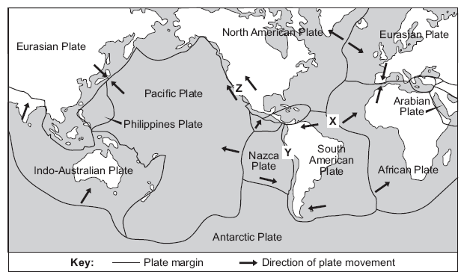
Figure 3

The Challenge of Natural Hazards Page 2
Question | A B C
- Define earthquake. | A sudden or violent movement within the earth’s crust followed by a series of shocks. | A sudden or violent explosion of lava erupting from the earth’s crust. | A violent storm with wind speeds of over 74mph.
- Define primary effect. | How people respond immediately after the hazard. | An effect that occurs during the hazard. | An effect that occurs later on, as a result of primary effects.
- Define secondary effect. | How people respond immediately after the hazard. | An effect that occurs during the hazard. | An effect that occurs later on, as a result of primary effects.
- Define immediate response. | How people respond months/years after the hazard. | How people respond straight after the hazard | An effect that occurs during the hazard.
- Define long term response. | How people respond straight after the hazard | An effect that occurs during the hazard. | How people respond months/years after the hazard.
KOBE:
- What type of plate margin was responsible for the earthquake? | Destructive | Constructive | Conservative
- What are the names of the two tectonic plate involved? | Philippines Plate & Eurasian Plate | Philippines Plate & North American | Eurasian Plate & North American
- When did it occur? | 17th January, 2010 | 17th January, 1995 | 17th January, 2005
- What was its magnitude? | 7.2 | 7.0 | 6.8
- How many people died? | 65,000 | 6,500 | 650,000
- What company’s office and factory was destroyed? | Toyota | Ford | Panasonic
- What elevated motorway was destroyed? | Great Hanshin Expressway | M11 | The Grand Expressway
- How many people were made homeless? | 4000 | 40,000 | 400,000
- Suggest a secondary effect that happened due to broken gas pipes. | Fires | Flooding | Injury
- What primary effect resulted in one million people having no water for ten days? | Death | Buildings collapse | Service pipes broke
- How much did the earthquake cost? | $220 billion | $120 billion | $320 billion
- How many people didn’t have access to electricity after the earthquake? | 3 million | 2 million | 1 million
- How many people helped in the aftermath (search and rescue)? | 0.4 million | 0.8 million | 1.2 million
- Identify two ways homes and buildings were improved in Kobe in response to the earthquake. | They started to use flexible steel frames that stay very rigid as the ground moves. | Rubber foundations were used that absorb the shockwaves/shaking. | Buildings were designed to have a larger base than top = less likely to fall over.
HAITI:
- What type of plate margin was responsible for the earthquake? | Conservative | Destructive | Collision
- What are the names of the two tectonic plate involved? | Eurasian & North American | Caribbean & Eurasian | Caribbean & North American
- When did it occur? | 12th January, 2010 | 12th January, 1990 | 12th January, 2000
- What was its magnitude? | 7.0 | 7.2 | 6.8
- How many people died? | 120,000 | 220,000 | 320,000
- How many schools and hospitals were destroyed? | 1000 schools and 8 hospitals | 2000 schools and 5 hospitals | 5000 schools and 8 hospitals
- How many homes were destroyed or damaged? | 200,000 | 100,000 | 300,000
- What was a secondary effect of the destroyed homes? | 1.3 million moved into temporary camps | 1.3 million moved in with relatives | 1.3 million people died
- How much did the earthquake cost? | $500 billion | $220 billion | $11.5 billion
- How did the USA immediately help? | Cleared rubble at the port, sent ships & helicopters to search and rescue for victims & gave $100 million for emergency aid | Sent police to keep order | Relocated the 1000s of people leaving Port-au-Prince.
- Which charity set up temporary hospitals? | Oxfam | Red Cross | WaterAid
- How did the World Bank help in the long term? | Set up evacuation centres | Gave $100 to support in building seismic instruments | Gave $100 million to support long term reconstruction
PLANNING & PREDICTION = PROTECTION
- Identify one way people can predict earthquakes | Measure for small tremors | Emergency Kits | Evacuation Routes
- Disaster Prevention Day occurs on 1st September in Japan each year. What do they practice on this day? | Earthquake Drills | How to create an emergency kit | How to use seismic instruments
- Is the answer to question 33 an example of prediction or planning? | -- | Planning | Prediction
- What is a hazard map? | A map used to prevent building on loose or weak ground. This prevents building on high risk areas. | A map used to prevent building on loose or weak ground. This prevents building on low risk areas. | A map used to prevent building on strong ground. This prevents building on low risk areas.
- Suggest one way a building can be made safer. | Make them wider at the top of the building than at the base. | Make the buildings out of glass. | Rubber foundations that absorb earthquake shockwaves.

The Challenge of Natural Hazards Page 2
Question
- Define earthquake.
- Define primary effect.
- Define secondary effect.
- Define immediate response.
- Define long term response.
KOBE:
- What type of plate margin was responsible for the earthquake?
- What are the names of the two tectonic plate involved?
- When did it occur?
- What was its magnitude?
- How many people died?
- What company’s office and factory was destroyed?
- What elevated motorway was destroyed?
- How many people were made homeless?
- Suggest a secondary effect that happened due to broken gas pipes.
- What primary effect resulted in one million people having no water for ten days?
- How much did the earthquake cost?
- How many people didn’t have access to electricity after the earthquake?
- How many people helped in the aftermath (search and rescue)?
- Identify one way homes and buildings were improved in Kobe in response to the earthquake.
HAITI:
- What type of plate margin was responsible for the earthquake?
- What are the names of the two tectonic plate involved?
- When did it occur?
- What was its magnitude?
- How many people died?
- How many schools and hospitals were destroyed?
- How many homes were destroyed or damaged?
- What was a secondary effect of the destroyed homes?
- What was the secondary effect of broken service lines (water, gas, electricity)?
- How much did the earthquake cost?
- How did the USA immediately help?
- Which charity set up temporary hospitals?
- How did the World Bank help in the long term?
PLANNING & PREDICTION = PROTECTION
- Identify one way people can predict earthquakes
- What occurs on 1st September in Japan?
- Is the answer to question 33 an example of prediction or planning?
- What is a hazard map?
- Suggest one way a building can be made safer.

THE CHALLENGE OF NATURAL HAZARDS PART 2 (page 2)

What is an earthquake? (2 marks)

Earthquakes are an example of a tectonic event. Describe the primary and secondary effects of earthquakes. (4 marks)

Study Figure A, a photograph showing an area affected by an earthquake in 2010, and Figure B, a photograph showing an area affected by a volcanic eruption in 2006.
- Use Figure A or Figure B and an example you have studied, to describe the primary and secondary effects of a tectonic event you have studied. (9 marks)
- Assess the extent to which primary effects are more significant than secondary effects. Use Figure A or Figure B and an example of you have studied. (9 marks)

Using an example of a volcanic eruption or earthquake you have studied, describe how people responded to the tectonic hazard. (6 marks)

Study Figure C, showing the largest and deadliest earthquakes from 2008 to 2012.
- To what extent is there a relationship between the largest and deadliest earthquakes shown in the table? (3 marks)
- Outline two reasons why the largest earthquakes do not always cause the most deaths. (4 marks)

Describe how the effects of an earthquake in a richer area of the world are different from the effects of an earthquake in a poorer area of the world. (6 marks)

Explain why people continue to live in areas at risk from earthquakes. (4 marks)

Study Figures 1, 2 and 3, photographs showing responses to the earthquake in Christchurch, New Zealand in 2010. Use Figures 1, 2 and 3 and your own knowledge to describe how the three Ps (predict, protect and prepare) can help to reduce the effects of earthquakes. (8 marks)

Describe how people could prepare for one of the following hazards: a volcanic eruption or an earthquake. (4 marks)

Describe how earthquake prone areas are monitored so that people can prepare for an eruption (4 marks)
Figure C

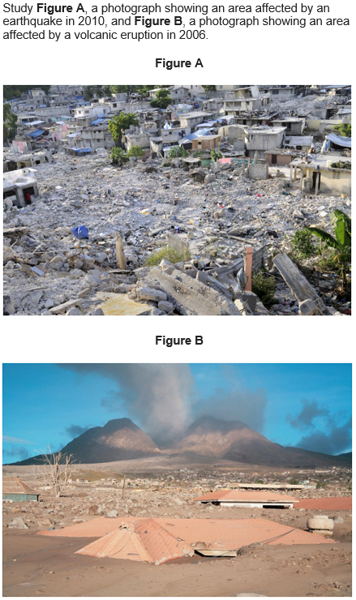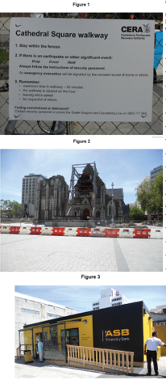

The Challenge of Natural Hazards Page 3
Question | A B C
- Define a tropical storm. | A storm with wind speeds of over 74mph and torrential rain | A storm with wind speeds of over 50mph and torrential rain | A storm with wind speeds of over 25mph and torrential rain.
- Give two conditions needed for a tropical storm to form. | Warm water (>27⁰C) and latitudes between 5-20⁰ | Warm water (>21⁰C) and latitudes between 5-20⁰ | Warm water (>27⁰C) and latitudes between 5-45⁰
- List the eight steps of tropical revolving storm formation. | Heat, evaporation, repeat/replace, condensation/cloud, spin/spiral, sinking air = eye, move, land/lose energy. | Heat, evaporation, condensation/cloud, spin/spiral = nose, move, land/lose energy. | Heat, evaporation, repeat/replace, condensation/cloud, spin/sink, move, land/lose energy.
- Tropical storms can be up to ……..m wide. | 200 | 300 | 100
- Identify the name of the centre of the storm where it is calm and there are no clouds. | Eye | Nose | Mouth
TYPHOON HAIYAN
- Where did it hit? | Philippines | Japan | China
- When did it occur? | November, 2003 | November, 1993 | November, 2013
- What category was the storm? | 4 | 5 | 3
- How fast were the winds and how high were the waves? | 150mph and 10m high | 200mph and 25m high | 170mph and 15m high
- How many people were killed? | 6,300 | 7,300 | 8,300
- What airport was destroyed? | Jakarta airport | Tacloban airport | Heathrow airport
- How many people were forced to evacuate to temporary camps | 1.1 million | 2.1 million | 1.6 million
- Identify the secondary effect that occurred due to the destroyed 30,000 fishing boats. | Death and disease | Loss of employment & income | Fires
- Identify the secondary effect that occurred due to the destroyed agricultural land? | $93 million of rice crops destroyed | $10 million of rice crops destroyed. | $53 million of rice crops destroyed
- How many evacuation centres were created? | 1200 | 1500 | 1700
- Give the name of the country that sent aircrafts and helicopters. | UN | USA | UK
- Which charity provided emergency food? | Philippine Red Cross | Oxfam | WaterAid
- Which countries provided emergency hospitals? | UK, France, Spain | Spain, Germany, Ireland | France, Belgium, Israel
- How did NGOs (e.g. Oxfam) help in the long term? | Built homes | Replaced fishing boats | Created cash for work programmes
PLANNING & PREDICTION = PROTECTION
- How are satellites used to predict tropical storms? | Satellites are used to track the tropical storm path. | Satellites are used to measure the temperature of the tropical storm. | Satellites are used to measure the number of people that are near the tropical storm.
- How can previous data be used to predict tropical storms? | Previous tropical storm data is used to measure how many people were affected in past storms. | Previous tropical storm data is used to track where previous storms travelled (tracks). | Previous tropical storm data is used to measure the temperature of past storms.
- Identify one way people prepare for future tropical storms. | Use satellites | Seismic instruments | Create an emergency kit
- How would evacuation routes help reduce risk? | People would know where to go during a tropical storm to prevent panic and loss of life. | People would have items on their possession to help them survive during a tropical storm. | People would have knowledge what to wear during a tropical storm.

The Challenge of Natural Hazards Page 3
Question
- Define a tropical storm.
- Give two conditions needed for a tropical storm to form.
- List the eight steps of tropical revolving storm formation.
- Tropical storms can be up to ……..m wide.
- Identify the name of the centre of the storm where it is calm and there are no clouds.
TYPHOON HAIYAN
- Where did it hit?
- When did it occur?
- What category was the storm?
- How fast were the winds and how high were the waves?
- How many people were killed?
- What airport was destroyed?
- How many people were forced to evacuate to temporary camps
- Identify the secondary effect that occurred due to the destroyed 30,000 fishing boats.
- Identify the secondary effect that occurred due to the destroyed agricultural land?
- How many evacuation centres were created?
- Give the name of the country that sent aircrafts and helicopters.
- Which charity provided emergency food?
- Which countries provided emergency hospitals?
- How did NGOs (e.g. Oxfam) help in the long term?
PLANNING & PREDICTION = PROTECTION
- How are satellites used to predict tropical storms?
- How can previous data be used to predict tropical storms?
- Identify one way people prepare for future tropical storms.
- How would evacuation routes help reduce risk?

THE CHALLENGE OF NATURAL HAZARDS PART 3 (page 3)

What is the difference between weather and climate? (2 marks)

Describe the conditions that lead to the formation of a tropical storm. (3 marks)

Explain how a tropical storm forms. You may use a diagram. (4 marks)

Study Figure 1. The statements show four stages in the life cycle of a tropical storm. With the help of the figure, describe the life cycle of a tropical storm. (3 marks)

Study Figure 2, a satellite image of Cyclone Nargis. Label features X, Y and Z. (3 marks)

Give two reasons why tropical storms eventually lose their energy. (2 marks)

Study Figure 3, a satellite image of Hurricane Katrina shortly before it crossed New Orleans in the USA.
- Using the image only, forecast the weather conditions in New Orleans over the next 24 hours

Study Figure 4, a map showing the path of a tropical storm (Typhoon Ketsana), 23 to 30 September, 2009. With the help of Figure 4, describe the primary and secondary effects of a tropical storm you have studied. (9 marks)

Study Figure 5, which describe responses to a tropical storm – Hurricane Katrina in New Orleans, USA in August 2005. Explain why the people of New Orleans were unhappy with the response of the authorities to Hurricane Katrina. (4 marks)

Use a case study to describe how people respond to a tropical revolving storm. (6 marks)

Study Figure 6, which shows information about methods of protection from the effects of tropical storms, and indicators of development for two countries.
- ‘Only more developed countries can protect themselves effectively from the damage caused by tropical storms’.
- Do you agree: Yes / No?
- Give reasons for your choice. Use Figure 6 and your own knowledge.
- Use examples from an area(s) that you have studied.

Study Figure 7, a map showing parts of two countries (A and B). The tropical storm will probably cause more damage in Country B. Suggest three reasons why. Use the information above. (3 marks)

In 2002, the Ganges Delta was hit by several tropical storms (cyclones). The table in Figure 8, gives some of the characteristics of the Ganges Delta. Using the table, explain why so many people die as a result of tropical storms in the Ganges Delta. (4 marks)

Study Figure 9, information about the Ganges Delta and effects of tropical storms in the area.
- Using the information in the figure, and your own knowledge, explain the likely effects of tropical storms in the Ganges Delta. (9 marks)
- Give three ways of reducing the damage caused by tropical storms, either in the long term or in the short term. (4 marks)

Study Figure 10, a notice board stating some methods of preparing for a tropical storm. Using Figure 6, and your own knowledge, describe how people can prepare for a tropical storm. (6 marks)
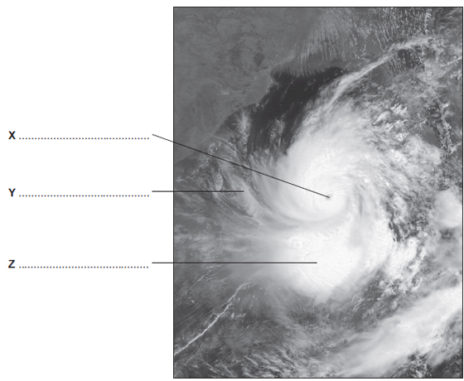
Figure 2
Describe how people can predict tropical storms to reduce future risk. (6 marks)

Suggest why the number of tropical storms may change in the future. (5 marks)
Figure 1

Figure 7
Figure 3
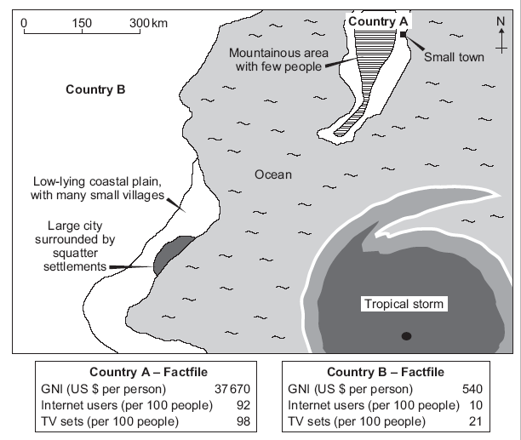

Figure 4

Figure 8

Figure 9
Figure 5
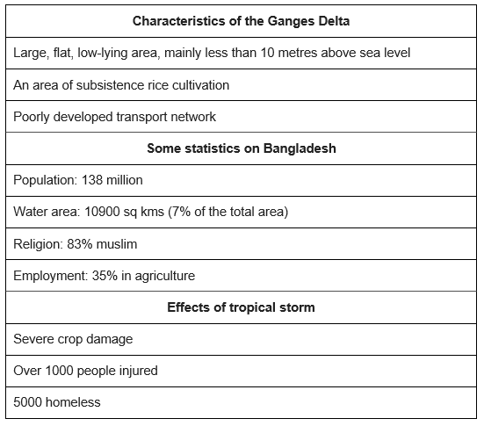
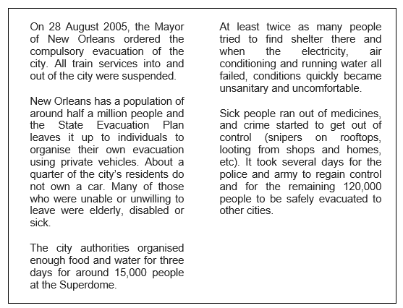

Figure 6
Figure 10

The Challenge of Natural Hazards Page 4
Question | A B C
- Define weather |  | The day-to-day conditions of the atmosphere. | The month-to-month conditions of the atmosphere | The year-to-year conditions of the atmosphere
- Define extreme weather |  | Weather events that are similar to normal | Weather events that involve a lot of rain. | Weather events that are significantly different from the normal.
- What did the International Disaster Database record? |  | An increase in the number of cold weather events since the 1960s | An increase in the number of floods since the 1960s. | An increase in the number of droughts since the 1960s
- What extreme weather events occurred in 2003, 2010 and 2014 in the UK? |  | Heatwave,  Big Freeze  Tsunami | Heatwave,  Big Freeze  Flooding | Heatwave,  Drought  Flooding
- In 2010 what temperature did the weather drop to? |  | -20⁰C | -10⁰C | -30⁰C
- Identify one positive & one negative effect of the extreme weather event in 2003. |  | Tourism income decreased and 2045 people died. | Tourism income increased, however 2045 people died. | The number of tourists doubled and 2500 people died.
SOMERSET FLOOD
- Where is Somerset? |  | South-west England | South-east England | Central England
- When did the flood occur? |  | January & March 2014 | February & March 2014 | January & February 2014
- How much rain fell in January & February? |  | 350mm | 250mm | 450mm
- List one other cause of the flood. |  | The rivers had not been dredged in 20 years | High tides & storm surges | Both A and B.
- List two social effects of the flood. |  | 600 homes were flooded and it cost Somerset Council £10 million. | 600 homes were flooded and villages were cut off | Floodwater containing sewage flooded farmland and villages were cut off.
- List two economic effect of the flood. |  | 14,000 hectares of agricultural land flooded and it cost Somerset Council £10 million | Power supplies were cut off and local railway lines needed fixing. | It cost £10,000 and 16 farms were evacuated.
- List one environmental effect of the flood. |  | It cost Somerset Council £10 million | 600 homes were flooded. | Floodwater containing sewage contaminated farmland
- What is dredging? |  | Raising the banks of the rivers. | Adding sediment to a river channel to make it larger | Removing sediment from river channels to make them larger
- What did they do to the river banks to prevent future floods? |  | Remove sediment from the banks to make them level | Raised them to create embankments | Dig ditches either side of the rivers.
- How did they prevent transport routes being affected by future floods? |  | Elevated roads | Lowered roads | Covered roads in a waterproof plastic.
- How did they help people plan for future floods? |  | Elevated roads | Dredged the rivers | Gave them flood defences (e.g. sandbags)
GLOBAL ATMOSPHERIC CIRCULATION
- What does warm air do? |  | Rises | Sinks | --
- What does cold air do? |  | Rises | Sinks | --
- What type of atmospheric air pressure do you find in regions where air rises? |  | Low | Medium | High
- What type of atmospheric air pressure do you find in regions where air sinks? |  | Low | Medium | High
- Identify typical weather at the poles. |  | Cold and dry | Hot and wet | Hot and dry
- Identify typical weather at the equator. |  | Cold and dry | Hot and wet | Hot and dry
- Identify typical weather at 30°N and 30°S. |  | Cold and dry | Hot and wet | Hot and dry
- What are the cells of air that circulate the earth called? |  | Hadley Cells | Radley Cells | Tadley Cells
- Due to the earth’s rotation, the winds move at an angle. This is called the…… |  | Convection Currents | Coriolis Effect | Continental Drift

The Challenge of Natural Hazards Page 4
Question
- Define weather
- Define extreme weather
- What did the International Disaster Database record?
- What extreme weather event occurred in 2003, 2010 and 2014?
- In 2010 what temperature did the weather drop to?
- Identify one positive & one negative effect of the extreme weather event in 2003.
SOMERSET FLOOD
- Where is Somerset?
- When did the flood occur?
- How much rain fell in January & February?
- List one other cause of the flood.
- List two social effects of the flood.
- List two economic effect of the flood.
- List one environmental effect of the flood.
- Identify one response by the Somerset county council to the Somerset floods
- What is dredging?
- What did they do to the river banks to prevent future floods?
- How did they prevent transport routes being affected by future floods?
- How did they help people plan for future floods?
GLOBAL ATMOSPHERIC CIRCULATION
- Define Global atmospheric circulation.
- What does warm air do?
- What does cold air do?
- What happens to atmospheric pressure as air rises?
- What happens to atmospheric pressure as air sinks?
- Identify typical weather at the poles.
- Identify typical weather at the equator.
- Identify typical weather at 30°N and 30°S.
- What are the cells of air that circulate the earth called?
- Due to the earth’s rotation, the winds move at an angle. This is called the……

Annotate the diagram to show how air moves around the earth.
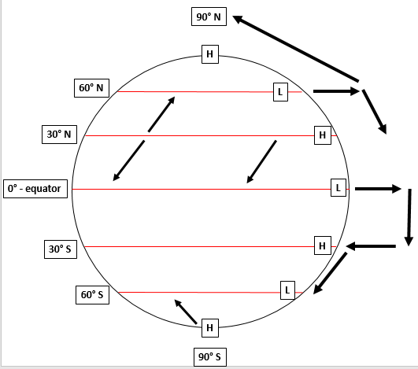

THE CHALLENGE OF NATURAL HAZARDS PART 4 (page 4)

Describe the characteristics of extreme weather. (3 marks)

The weather in the UK is becoming more extreme. Use evidence to support this statement. (6 marks)

Study Figure 1a, a satellite image of the British Isles taken on 2nd December, 2010 and Figure 1b, a newspaper extract.
- Describe the extent of snow cover shown in Figure (2 marks)
- Use examples to describe the impacts of extreme weather such as that shown in Figures 1a and 1b. (6 marks)
- Discuss issues raised in preparing for and dealing with the impacts of extreme weather such as that shown in Figures 1a and 1b. (6 marks)

Study Figure 2, a variety of newspaper headlines about weather in the UK.
- Explain how the newspaper headlines show that the UK experiences extreme weather (2 marks)
- Describe the benefits that extreme weather can bring (4 marks)

Study Figure 3, which shows the locations of flood events in England between 2000 and 2007.
- Use a case study to describe the social, economic and environmental effects of river flooding in the UK. (9 marks)
- Use a case study to explain how the risk of river flooding can be reduced. (6 marks)

Describe and explain the weather found along the equator. (4 marks)

Describe and explain the weather found along the Tropic of Capricorn and Tropic of Cancer. (4 marks)

Describe how the earth’s rotation affects global wind patterns. (6 marks)

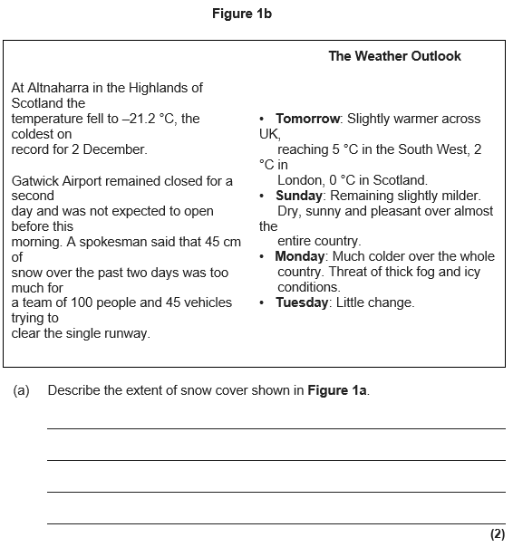
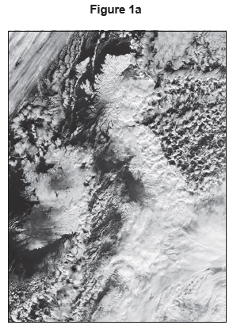

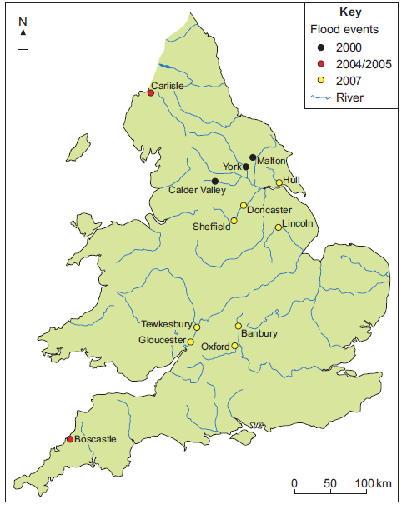
Figure 3
Figure 2
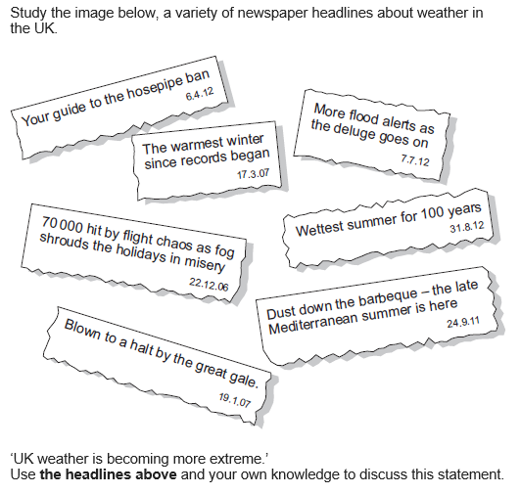

The Challenge of Natural Hazards Page 5
Question | A B C
- Define climate change |  | A change in the earth’s climate | A weather event that is significantly different to normal | An event with wind speeds over 74mph
- How much has global temperature risen in the last 100 years? |  | 0.5⁰C | 0.74⁰C | 1.2⁰C
- Over the last 20 years arctic ice has……….. |  | Thinned to half its thickness | Thinned to a third of its thickness | Doubled in size
- Photographs have shown that glaciers have…… |  | Retreated in the last 5-10 years | Retreated in the last 50-100 years | Got bigger
- Paintings show that in 1677 the River Thames was…… |  | Half as deep as today | Hotter than today | Frozen
NATURAL CAUSES OF CLIMATE CHANGE
- State what happens to the temperature of the earth when there is a volcanic eruption? |  | It gets warmer | It gets colder | It stays the same
- What is a sunspot? |  | A dark patch on the sun | A light patch on the sun | --
- When there are few sunspots, the temperature drops. In 1645-1715 there were very few sunspots. This resulted in…… |  | Global warming, known as the Medieval Warm Period | The temperature staying exactly the same. | Global cooling, known as the Little Ice Age
- Identify the length of a sunspot cycle |  | 8 years | 11 years | 14 years
- Define orbital change. |  | A change in how the earth moves around the sun | A change in how the sun moves around the earth | A change in how the moon moves around the earth
- Define eccentricity. |  | How the moon orbits the earth | How the sun orbits the earth | How the earth orbits the sun
- Identify the length of an eccentricity cycle |  | 100,000 years | 50,000 years | 150,000 years
- How does eccentricity affect the earth’s temperature? |  | It affects how far the moon is from the sun. | It affects how close the earth is from the sun. | It affects how far the moon is from the earth
HUMAN CAUSES OF CLIMATE CHANGE
- List three fossil fuels |  | Coal, oil, gas | Solar, coal, gas | Geothermal, gas, oil
- Define the enhanced greenhouse effect. |  | The presence of greenhouse gases in the atmosphere due to natural processes. | The presence of extra greenhouse gases in the atmosphere due to human actions. | The removal of greenhouse gases in the atmosphere due to human actions.
- Sunlight travels to the earth as…………….. radiation, however is reflected off the earth’s surface as…………..radiation. |  | Longwave  Shortwave | Infrared  Shortwave | Shortwave  Longwave
- How have humans caused an increase in methane production? |  | Increased demand for beef = more cattle that produce methane. | Increase demand for electricity = more fossil fuels burnt | Increased use of cars and airplanes that release nitrous oxide.
- How have humans caused an increase in carbon dioxide production? |  | Increased demand for beef = more cattle that produce methane. | Increase demand for electricity = more fossil fuels burnt | Increased use of cars and airplanes that release nitrous oxide.
- How have humans caused an increase in nitrous oxide production? |  | Increased demand for beef = more cattle that produce methane. | Increase demand for electricity = more fossil fuels burnt | Increased use of cars and airplanes that release nitrous oxide.
- How does deforestation result in global warming? |  | More CO2 is removed during photosynthesis = less greenhouse gases in the atmosphere. | More CO2 is removed during photosynthesis = more greenhouse gases in the atmosphere. | Less CO2 is removed during photosynthesis = more greenhouse gases in the atmosphere.
MITIGATION & ADAPTATION
- Define mitigation |  | Adapting lifestyles to cope with the likely impacts of climate change. | Increasing the amount of greenhouse gases in the atmosphere. | Reducing the amount of greenhouse gases in the atmosphere.
- How can carbon capture mitigate against climate change? |  | Carbon dioxide produced at factories is captured and stored in oceans or underground = less in the atmosphere. | Carbon dioxide produced at factories is released into the atmosphere. | Carbon dioxide produced at factories is stored in massive metal containers at the factory so less is in the atmosphere.
- Why does afforestation affect the amount of greenhouse gases in the atmosphere? |  | Planting trees = more photosynthesis occurs = more CO2 removed. | Removing trees = more photosynthesis occurs = more CO2 removed. | Removing trees = less photosynthesis occurs = more CO2 removed.
- What happened in 2005? |  | The Paris Agreement | The Kyoto Protocol | The Copenhagen Meeting
- What happened in 2015? |  | The Paris Agreement | The Kyoto Protocol | The Copenhagen Meeting
- Define adaptation. |  | Adapting lifestyles to cope with the likely impacts of climate change. | Increasing the amount of greenhouse gases in the atmosphere. | Reducing the amount of greenhouse gases in the atmosphere.
- Why will sea level likely rise? |  | Increase in temperatures = ice caps melt = sea levels rise | Decrease in temperatures = ice caps melt = sea levels rise | Increase in temperatures = ice caps freeze = sea levels rise
- Identify one way people can adapt to likely sea level rise? |  | Build homes on low lying ground | Increase the number of coastal sea defences. | Relocate all people who live in coastal areas.
- Why will pests and diseases be a likely impact of climate change? |  | Most pests live in warm climates. Increased temperature = pests more common in more areas. | Most pests live in cold climates. Decreasing temperatures = more pests common in more areas. | Most pest live in warm climates. Increased temperature = pests less common in more areas.
- Identify one way people can adapt to likely extreme weather events (e.g. droughts) |  | Use GM crops | Use irrigation schemes | Answers to both A and B
- Why will there be a lack of water supply? |  | Extreme weather events are more likely, such as floods. | Extreme weather events are more likely, such as droughts. | Extreme weather events are less likely.
- Identify one way people can adapt to likely unreliable rainfall and a lack of water supply. |  | Answers to both B and C | Use irrigation schemes (e.g. drip irrigation) | Recycle water (greywater)

The Challenge of Natural Hazards Page 5
Question
- Define climate change
- How much has global temperature risen in the last 100 years?
- Over the last 20 years arctic ice has………..
- Photographs have shown that glaciers have……
- Paintings show that in 1677 the River Thames was……
NATURAL CAUSES OF CLIMATE CHANGE
- State what happens to the temperature of the earth when there is a volcanic eruption.
- What is a sunspot?
- When there are few sunspots, the temperature drops. In 1645-1715 there were very few sunspots. This result in……
- Identify the length of a sunspot cycle
- Define orbital change.
- Define eccentricity.
- Identify the length of an eccentricity cycle
- How does eccentricity affect the earth’s temperature?
HUMAN CAUSES OF CLIMATE CHANGE
- List three fossil fuels
- Define the enhanced greenhouse effect.
- Sunlight travels to the earth as…………….. radiation, however is reflected off the earth’s surface as…………..radiation.
- How have humans caused an increase in methane production?
- How have humans caused an increase in carbon dioxide production?
- How have humans caused an increase in nitrous oxide production?
- How does deforestation result in global warming?
MITIGATION & ADAPTATION
- Define mitigation
- How can carbon capture mitigate against climate change?
- Why does afforestation affect the amount of greenhouse gases in the atmosphere?
- What happened in 2005?
- What happened in 2015?
- Define adaptation.
- Why will sea level likely rise?
- Identify one way people can adapt to likely sea level rise?
- Why will pests and diseases be a likely impact of climate change?
- Identify one way people can adapt to likely extreme weather events (e.g. droughts)
- Why will there be a lack of water supply?
- Identify one way people can adapt to likely unreliable rainfall and a lack of water supply.

THE CHALLENGE OF NATURAL HAZARDS PART 5 (page 5)

What is global climate change? (2 marks)

There is significant evidence of long term climate change. Use evidence to support this statement. (6 marks)

Study Figure 1, a graph showing changes in the amount of carbon dioxide in the atmosphere. Describe the change in the amount of carbon dioxide in the atmosphere shown in the graph. (2 marks)

Study Figure 2, a chart showing information about global warming.
- Describe how the concentration of carbon dioxide has changed since 1960. (3 marks)
- With the help of the information explain possible human causes of global warming. (6 marks)

Explain how population rise has affect global temperatures. (6 marks)

Study Figure 3, a map showing the extent of sea ice in the Arctic Ocean on 26th August, 2012.
- Describe the changes in the extent of Arctic sea ice shown in the map. (2 marks)
- Suggest reasons for the changes in the extent of Arctic sea ice shown in the map. (4 maps)

Study Figure 4, a graph showing average annual maximum temperatures at Heathrow Airport, London from 1950 to 2010.
- Describe the trends shown in the graph. (4 marks)
- Describe the possible effects of climate change on the UK. (4 marks)

Study Figure 5, which shows predicted global, Northern Hemisphere and Southern Hemisphere temperature change.
- Describe the trends shown by the graph. (4 marks)
- Outline two natural causes of global climate change. (4 marks)
- Describe the possible environmental and social consequences of climate change for the UK. (6 marks)

Describe and explain the global response(s) to the threat of climate change. (8 marks)

Describe what is being done to respond to the threat of climate change at an international level. (6 marks)

Study Figure 6, a diagram showing changing sea levels between 1993 and 2010. Describe the possible economic and environmental effects of rising sea level. (6 marks)

The Kyoto Agreement was aimed at controlling pollution by reducing the amount of carbon dioxide being released into the atmosphere.
- Is this an example of mitigation or adaptation? (1 mark)
- Describe how the amount of carbon dioxide being released can be reduced. (2 marks)
- Explain why the control of pollution needs to be agreed by many countries if it is to be successful. (2 marks)

Study Figure 7, a compound graph showing the amount of carbon produced in different parts of the world. Describe the changing pattern of carbon emissions shown in the figure.

Describe how countries can mitigate against climate change. (6 marks)

Rising sea levels are a major consequence of global warming. How may the problem of rising sea levels be managed? (4 marks)

Deforestation in tropical rainforests is one of the reasons for an increasing greenhouse effect around the earth. Explain how it has helped to increase the greenhouse effect. (6 marks)

Describe how people have adapted to the likely impacts of global climate change. (6 marks)

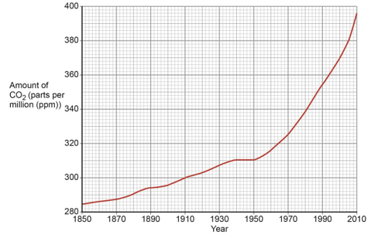

Figure 2
Figure 1

Figure 4

Figure 3

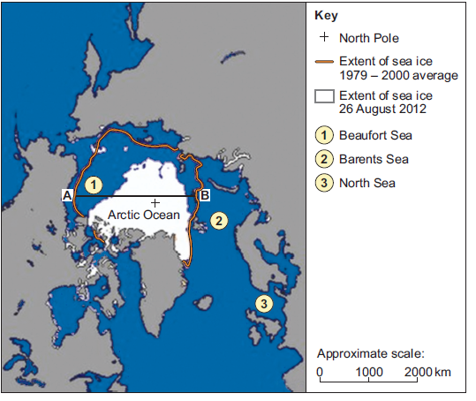

Figure 6

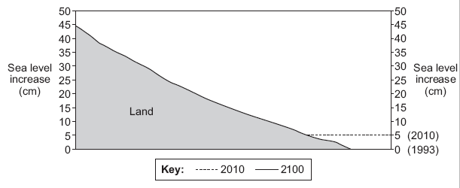

Figure 5
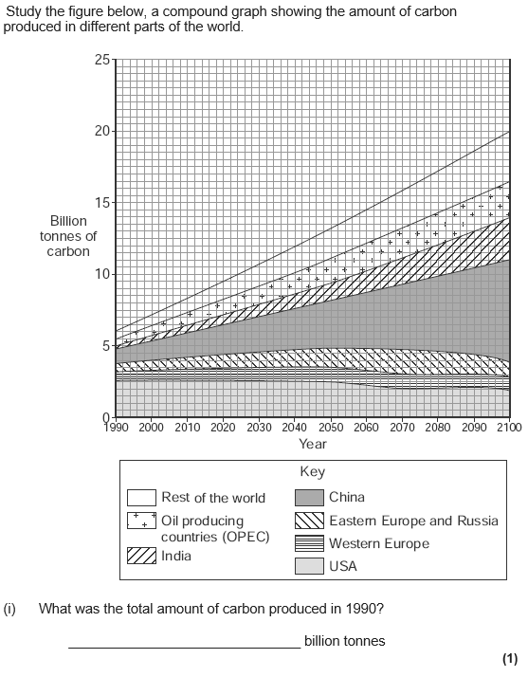
Figure 7
