|  |  |  |  |  |
| --- | --- | --- | --- | --- |
| Physical Landscapes in the UK - Coasts Page 11 | | | | |
| Question | **A B C** | | | |
| 1. What is wave length? | | The distance between the trough and the crest of a wave. | The distance between two wave crests. | The base of a wave. |
| 1. What is wave height? | | The distance between the trough and the crest of a wave. | The distance between two wave crests. | The top of a wave. |
| 1. What distance do waves travel? | | In the direction of the fetch | In the direction of the prevailing wind. | In the direction of the coastline |
| 1. Identify one factor that affects the strength of waves. | | Wave height | Swash | Wave fetch |
| 1. Identify two characteristics of constructive waves. | | Strong swash | Low wave height | Strong backwash |
| 1. Identify two characteristics of destructive waves. | | Weak backwash | High wave height | Strong backwash |
| 1. What does wave fetch mean? | | The distance between the trough and the crest of a wave. | The distance of water over which the wind blows (the size of the sea/ocean) | The movement of material by the sea. |
| 1. Define coastal erosion. | | The breakdown of rocks caused by day-to-day changes in the atmosphere. | The wearing away of rocks by the sea | The movement of material by the sea. |
| 1. What is hydraulic action? | | The force of water hitting against the cliff removes material. | Chemicals in the water react with the rock and break it down. | Material in the sea hits against the cliff and removes material (similar to sandpaper) |
| 1. What is abrasion? | | The force of water hitting against the cliff removes material. | Chemicals in the water react with the rock and break it down. | Material in the sea hits against the cliff and removes material (similar to sandpaper) |
| 1. Define weathering. | | The breakdown of rocks caused by day-to-day changes in the atmosphere. | The wearing away of rocks by the sea | The movement of material by the sea. |
| 1. Describe the process of freeze thaw weathering. | | Soft rocks expand if they get wet and contract when they dry. Repeated expanding and contracting = cracks appear. | Water collects in cracks. Freezes overnight and expands. In the day it melts, overtime the rock breaks and falls apart. | Plant roots grow in cracks in the rocks and break them apart. |
| 1. Describe the process of carbonation. | | Plant roots grow in cracks in the rocks and break them apart. | Soft rocks expand if they get wet and contract when they dry. Repeated expanding and contracting = cracks appear. | Chemicals in the water react with the rocks (e.g. carbonic acid) |
| 1. Define swash | | The water that flows back to the sea after the waves break. | Breaking waves rush water and sediment up the beach. | The transportation of material within the waves. |
| 1. Define backwash | | The water that flows back to the sea after the waves break. | Breaking waves rush water and sediment up the beach. | The transportation of material within the waves. |
| 1. How is material transported along the coastline? | | Through a series of 90⁰ angle between the swash and backwash. | In a straight line pattern, through the processes of deposition. | In a zig zag pattern, through the process of longshore drift. |
| 1. Outline the process of longshore drift. | | Waves hit the beach at an angle = the swash carries material up the beach at an angle. The backwash removes material back to the sea at a 90⁰ angle. This repeated process transports material along the coastline in a zig zag pattern. | The breakdown of rocks caused by day-to-day changes in the atmosphere. | The dropping of material carried by the sea. |
| 1. Define deposition. | | The picking up of sediment | The dropping of material carried by the sea. | The removal of sediment |
| 1. Identify the cause of deposition. | | Decrease in energy | Decrease in fetch | Decrease in wave size |
| 1. Suggest one location where deposition occurs along the coastline. | | An exposed headland | Lower course of the coast | In a sheltered bay |
| 1. What process do destructive waves cause? | | Deposition | Erosion | Transportation |
| 1. What process do constructive waves cause? | | Deposition | Erosion | Transportation |
| 1. Define infiltration. | | The process where liquid goes into the ground rock. | The process where the a liquid runs over rocks | The process where vegetation captures water |
| 1. Define saturation. | | Rock that cannot absorb water | Rock that is full of liquid. | A large collection of rocks in one particular bay |
| 1. What is the difference between permeable and impermeable rock? | | Permeable rocks are less resistant than impermeable rocks | Impermeable rocks are less resistant than permeable rocks | Permeable rock allows liquid to infiltrate. Impermeable rock doesn’t allow liquid to infiltrate. |
| 1. What is a slip plane? | | A line of weakness, along which movement occurs. | A gentle slopping coast line | Smooth face of a wave cut platform |

|  |
| --- |
| Physical Landscapes in the UK - Coasts Page 11 |
| Question |
| 1. What is wave length? |
| 1. What is wave height? |
| 1. What distance to waves travel? |
| 1. Identify one factor that affects the strength of waves. |
| 1. Identify two characteristics of constructive waves. |
| 1. Identify two characteristics of destructive waves. |
| 1. Define coastal erosion. |
| 1. What does wave fetch mean? |
| 1. What is hydraulic action? |
| 1. What is abrasion? |
| 1. Define weathering. |
| 1. Describe the process of freeze thaw weathering. |
| 1. Describe the process of carbonation. |
| 1. Define swash |
| 1. Define backwash |
| 1. How is material transported along the coastline? |
| 1. Outline the process of longshore drift. |
| 1. Define deposition. |
| 1. Identify the cause of deposition. |
| 1. Suggest one location where deposition occurs along the coastline. |
| 1. What process do destructive waves cause? |
| 1. What process do constructive waves cause? |
| 1. Define infiltration. |
| 1. Define saturation. |
| 1. What is the difference between permeable and impermeable rock? |
| 1. What is a slip plane? |

**PHYSICAL LANDSCAPES IN THE UK: COASTS - PART 1 (page 11)**

The following statements are about the different types of weathering. Write the correct type of weathering (mechanical, chemical or biological) next to each statement. (3 marks)

* A change in both the appearance and the mineral composition of the rock.
* The effects of plant roots or burrowing animals on rock.
* The breaking down of rock into smaller pieces without changing its composition.

Describe how two examples of weathering affect the coastline. (4 marks)

The following statements are about processes that affect the coast. Write the correct process (weathering, mass movement, erosion or transportation) next to each box. (3 marks)

* Material slides down a slope.
* Particles of sand are bounced along the beach.
* Temperatures rise above and fall below freezing causing ice to thaw and water to freeze.

Name and describe two processes of coastal erosion. (4 marks)

Figure 1 shows the process of longshore drift.

1. Write labels for X, Y and Z. (2 marks)
2. Describe how longshore drift transports material along the coastline. (4 marks)
3. Give two landforms that result from longshore drift. (2 marks)

Draw a labelled diagram to show the process of longshore drift. (3 marks)

Explain why deposition occurs at certain places along the coast. (3 marks)

Explain how waves form in the ocean and break at the coastline. (4 marks)

Compare how constructive and destructive waves differ. (4 marks)

Complete the diagram below to show how natural coastal systems work. Use these key terms:

* Deposition, erosion, weathering, transportation.

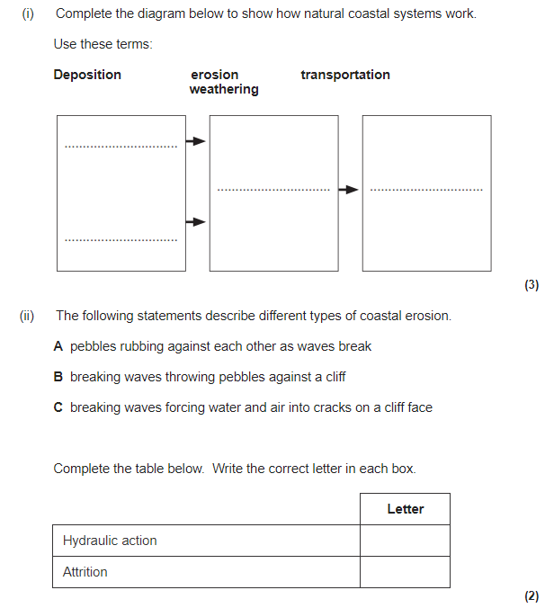

**Figure 1**

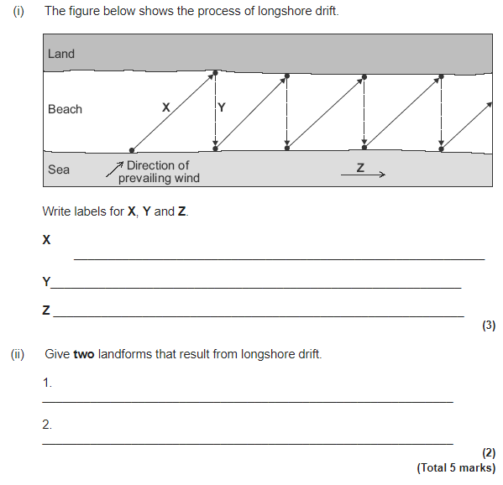

|  |  |  |  |  |
| --- | --- | --- | --- | --- |
| Physical Landscapes in the UK - Coasts Page 12 | | | | |
| Question | **A B C** | | | |
| **MASS MOVEMENT** | |  | | |
| 1. What is mass movement? | | The downhill movement of material caused by gravity. | The uphill movement caused through weathering | The wearing down and transportation of material along the coast |
| 1. What 2 processes cause mass movement? | | Deposition | Weathering | Erosion |
| 1. Rotational slump is an example of mass movement. Suggest one other. | | Rockfall | Headland and Bay | Wave-cut platform |
| 1. Explain the process of rotational slump. | | Rainfall infiltrates rock making it saturated and heavy. The heavy rock becomes unstable and a curved line of weakness forms. Eventually the land slumps down the curved line of weakness. | Freeze-thaw weakens the rocks at the top of the cliff.  These weakened rocks fall due to gravity to the base of the cliff.  The material that collects at the bottom of the cliff is called a scree slope. | Heavy rain infiltrates soil and rock = saturated and heavier. The rock becomes unstable.  A line of weakness (slip plane) forms. The heavy rain soaked material falls down the slope, along a line of weakness. |
| **EROSIONAL LANDFORMS** | |  | | |
| 1. List two erosional landforms found along the coastline. | | Beach | Headland and Bay | Wave-cut platform |
| 1. In what erosional landform do you find a wave cut notch and overhanging cliff? | | Wave-cut platform | Headland and bay | Cave, arch, stack |
| 1. What erosional landform is caused by differential erosion? | | Sand dunes | Spit | Headland and bay |
| 1. What is a discordant coastline? | | When there are two types of rock along the coastline that have different rates of erosion. | Where there are two types of rock running parallel to the coast line. | A coast line with especially less resistant rock. |
| 1. In what erosional landform do you find a stump? | | A headland | A bay | A stack |
| 1. What processes results in the formation of a wave-cut platform | | Erosion | Transportation | Deposition |
| 1. What is a headland? | | An indentation in the coastline. | A cliff that sticks out into the sea. | A platform of rock found at the base of a cliff. |
| 1. What is a bay? | | An indentation in the coastline. | A cliff that sticks out into the sea. | A platform of rock found at the base of a cliff. |
| 1. What is a wave cut platform? | | An indentation in the coastline. | A cliff that sticks out into the sea. | A platform of rock found at the base of a cliff. |
| **DEPOSITIONAL LANDFORMS** | |  | | |
| 1. List two depositional landforms. | | Cave, arch, stack | Beach | Spit |
| 1. In what depositional landform do you find a recurved end and salt marsh? | | Spit | Bar | Headland and bay |
| 1. What is the offshore, foreshore and backshore? | | Different parts of the beach. | Course along the coast line | Different parts of the coast where erosion occurs |
| 1. What type of waves cause a sandy beach? | | -- | Constructive | Destructive |
| 1. What type of waves cause a pebble beach? | | -- | Constructive | Destructive |
| 1. What is a sand dune? | | Large mounds of sand found at the back of the beach. | A sheltered area where marsh land and sand builds up. | Depositional landforms created through longshore drift. |
| 1. Why does sand collect and build up? | | Longshore drift | Obstacles (e.g. driftwood) traps sand being blown inland | Erosion and transportation |
| 1. List one difference between an embryo dune and mature dune. | | Mature dunes are more heavily vegetated. | Mature dunes are grey in colour | Embryo dunes are taller and newer |
| 1. What is as spit? | | Deposits of sand or shingle at the coastline. | Large mounds of sand found at the back of the beach. | A strip of sand and material that extends out from the coastline into the sea. |
| 1. What two processes result in spit formation? | | Erosion and deposition | Transportation and deposition | Transportation and erosion |
| 1. Why do spits have a recurved end? | | Due to strong winds and waves. | Due to the strength of the backwash | Due to the longshore drift |
| 1. Why do salt marshes form behind a spit? | | The spit leaves the area behind it exposed = erosion. | The spit shelters the area behind it = deposition. | The material transported along the spit is blown behind the spit. |
| 1. If a spit joins another headland, what is it called? | | Tombolo | Bar | Beach |
| 1. If a spit joins an island, what is it called? | | Tombolo | Bar | Beach |

|  |
| --- |
| Physical Landscapes in the UK - Coasts Page 12 |
| Question |
| **MASS MOVEMENT** |
| 1. What is mass movement? |
| 1. What process results in mass movement? |
| 1. Rotational slump is an example of mass movement. Suggest one other. |
| 1. Explain the process of rotational slump. |
| **EROSIONAL LANDFORMS** |
| 1. List two erosional landforms found along the coastline. |
| 1. In what erosional landform do you find a wave cut notch and overhanging cliff? |
| 1. What erosional landform is caused by differential erosion? |
| 1. What is a discordant coastline? |
| 1. In what erosional landform do you find a stump? |
| 1. Explain how a wave cut notch is formed. |
| 1. What is a headland? |
| 1. What is a bay? |
| 1. What is a wave cut platform? |
| **DEPOSITIONAL LANDFORMS** |
| 1. List two depositional landforms. |
| 1. In what depositional landform do you find a recurved end and salt marsh? |
| 1. What is the offshore, foreshore and backshore? |
| 1. What type of waves cause a sandy beach? |
| 1. What type of waves cause a pebble beach? |
| 1. What is a sand dune? |
| 1. Why does sand collect and build up? |
| 1. List one difference between an embryo dune and mature dune. |
| 1. What is as spit? |
| 1. What two processes result in spit formation? |
| 1. Explain how a spit is formed. |
| 1. Why do spits have a recurved end? |
| 1. Why do salt marshes form behind a spit? |
| 1. If a spit joins another headland, what is it called? |
| 1. If a spit joins an island, what is it called? |

**PHYSICAL LANDSCAPES IN THE UK: COASTS - PART 2 (page 12)**

Mass movement is a process affecting the coastal zone.

1. What is meant by the term mass movement? (2 marks)
2. What is cliff collapse? (2 marks)
3. Explain why cliffs collapse. (4 marks)

Using an example, explain why some areas of the coast are likely to collapse into the sea. (6 marks)

Study Figure 1, a photograph of North Landing, Flamborough Head and Figure 2, a sketch of Figure 1.

1. Label landforms X, Y and Z (3 marks)
2. Explain how processes of erosion have formed the stack shown above. (5 marks)

Study Figure 3, a photograph of the coast in Cornwall. This photograph shows a headland (X) and wave cut platform (Y).

1. Explain the formation of a headland and bay. (4 marks)
2. Explain the formation of a wave cut platform. (4 marks)

Study Figure 4, a sketch map showing features of coastal deposition.

1. Identify the depositional landforms on the figure. (3 marks)
2. Explain the formation of a spit. (4 marks)
3. Outline how a bar is different from a spit. (2 marks)
4. Outline how the formation of a sandy beach and pebble beach differ (3 marks)

Study Figure 5, a simplified map of part of the Dorset coast. Different types of rock are found in this area.

1. Give one pieces of evidence from the figure that suggests clays and sands are the softest rocks. (1 mark)
2. How might the coastline around Stair Hole change in the future? Use the figure to help you. (4 marks)

Study Figure 6, showing a coastal spit.

1. Complete the diagram using the following key terms: *mudflats, neck of spit, saltwater lake, recurved end, salt marsh* (4 marks)
2. Explain why a saltmarsh forms behind a spit. (3 marks)

Explain the formation of a coastal bar. You may use a diagram to support your answer. (6 marks)

Study Figure 7, photographs of dunes at Studland in Dorset.

1. Describe the vegetation of the coastal habitat shown at X, Y and Z. (3 marks)
2. Describe how the vegetation changes from near the sea to further inland. (4 marks)

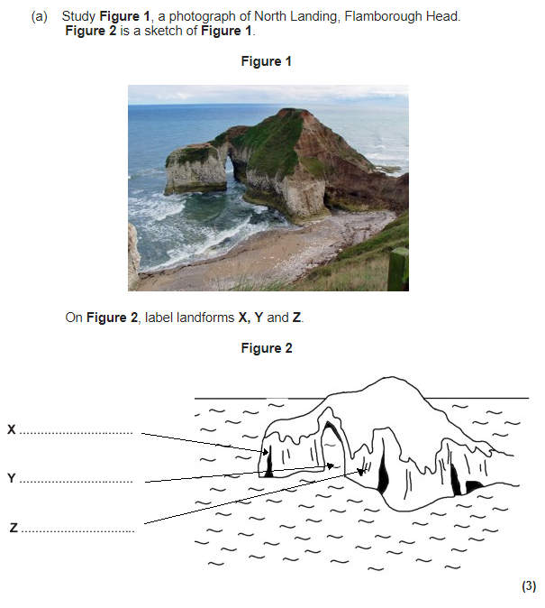

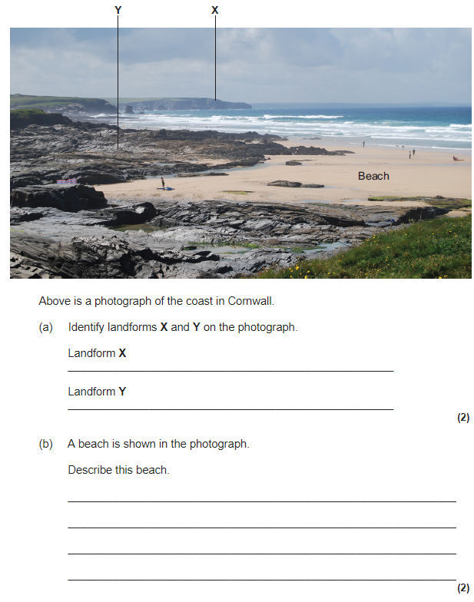

**Figure 3**

**Figure 5**

**Figure 4**

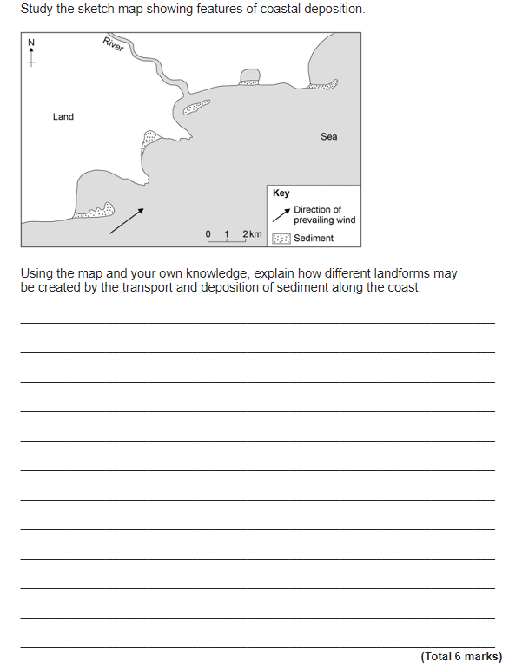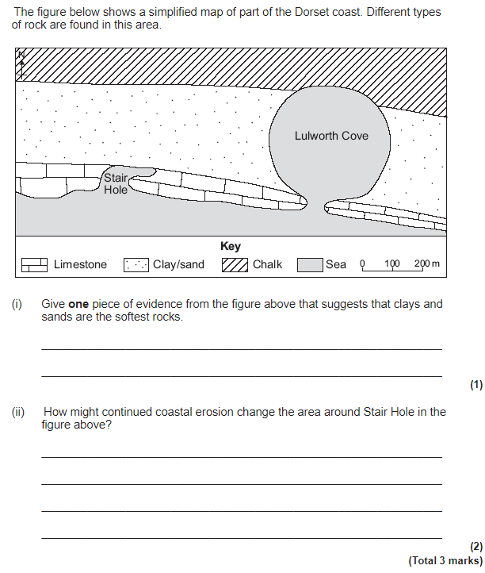

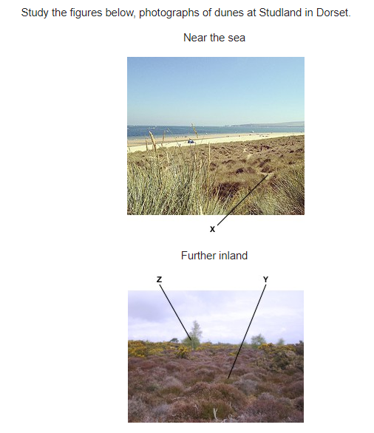

**Figure 7**

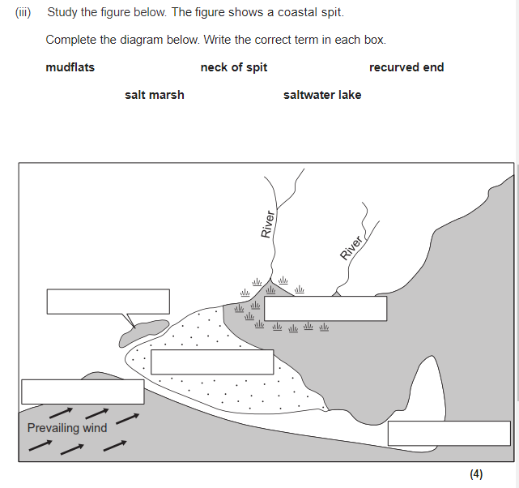

**Figure 6**

|  |  |  |  |  |
| --- | --- | --- | --- | --- |
| Physical Landscapes in the UK - Coasts Page 13 | | | | |
| Question | **A B C** | | | |
| 1. What is a Shoreline Management Plan? | | A plan that outlines how the coast will be managed. | A plan that encourages the rate of erosion. | A plan that outlines how the river will be protected |
| 1. List the four SMP strategies. | | Advance the line,  Hold the line,  Managed retreat Do nothing | Advance the line Hold the coastline Managed retreat  Do nothing | Advance the line Hold the line Managed retention Do nothing |
| 1. What is cost benefit analysis? | | The cost of the land must be more than the value of the land it is protecting. | The cost of the land must be less than the value of the land it is protecting. | The cost of the land must be less than the length of the land it is protecting. |
| **HARD ENGINEERING** | | | | |
| 1. Define hard engineering. | | Using manmade artificial structures to prevent deposition and flooding. | Using natural structures to prevent erosion and flooding. | Using manmade artificial structures to prevent erosion and flooding. |
| 1. List two examples of hard engineering. | | Rock armour, gabions | Groynes, beach reprofiling | Sea wall, dune regeneration |
| 1. What is the purpose of hard engineering strategies? | | To absorb the wave’s energy | To stop natural processes | To reduce the amount of sediment. |
| 1. Describe rock armour and identify an advantage of using it. | | Rock armour is large rocks placed in front of the cliff.  They have a long life span. | Rock armour is large rocks placed in front of the cliff.  They are cheap to use. | Rock armour is large rocks placed in the sea. They have a long life span. |
| 1. How does a curved sea wall protect the coastline? | | Traps sediment being transported along the coastline. | Prevents the deposition of material. | Deflects the wave energy back into the sea. |
| 1. Groynes are wood or rock fences built out into the sea. How do they protect the coastline? | | Groynes trap sediment being transported along the coastline. | Groynes prevent the erosion of sediment along the coastline | Groynes absorb the wave’s energy. |
| 1. What is offshore breakwater and identify one way they protect the coastline? | | An offshore breakwater is a rock fence built out into the sea.  They reduce the wave energy. | Offshore breakwater are large rocks placed in the sea, that are parallel to the coastline. They increase the wave energy before it hits the beach. | Offshore breakwater are large rocks placed in the sea, that are parallel to the coastline. They absorb the wave’s energy before it reaches the coastline. |
| 1. Suggest one advantage and one disadvantage of using gabions. | | They can look natural if covered in vegetation, however the wire cages can break and be dangerous. | They have a long lifespan, however are ineffective. | They can look natural if covered in vegetation, however are more expensive that rock armour. |
| 1. Suggest one disadvantage of using groynes. | | They are expensive. | The big beaches prevent tourism | They stop sediment transporting along the beach. |
| **SOFT ENGINEERING** | |  | | |
| 1. Define soft engineering | | Soft engineering uses natural environmentally friendly methods to prevent erosion & flooding. | Soft engineering uses artificial methods to prevent erosion and flooding. | Soft engineering uses natural, environmentally friendly methods to increase erosion&flooding. |
| 1. List two examples of soft engineering. | | Beach nourishment and dune regeneration | Beach feeding and dune fencing | Beach nourishment and beach fencing |
| 1. What is the purpose of soft engineering strategies? | | To create a natural barrier between the sea and cliffs/settlement. | To create an artificial barrier between the sea and cliffs/settlement. | To prevent a natural barrier forming between the sea and cliffs/settlement. |
| 1. Describe beach nourishment and list one advantage. | | Adding sediment to the beach, it is cheaper. | Adding sediment to the beach, it requires a lot of maintenance. | Adding sediment to the beach, it has ha long lifespan. |
| 1. Describe beach re-profiling and list one advantage. | | Material removed from the beach due to longshore drift is returned. This makes the beach larger, creating a protective barrier from the sea. | Material removed from the beach due to longshore drift is returned. This makes the beach smaller, creating a protective barrier from the sea. | Material removed from the beach due to longshore drift is returned. This encourages the creation of sand dunes. |
| 1. What does dune regeneration achieve? | | It creates a natural barrier from the waves | It creates an artificial barrier from the waves | It prevents sand dunes from forming. |
| 1. Why does dune fencing achieve? | | The fences act as a barrier from the waves | The fences act as an obstacle and trap sediment, creating new sand dunes. | The fences prevent the build-up of sediment. |
| 1. Suggest one advantage and one disadvantage of using beach nourishment. | | More tourism  Requires regular maintenance | Creates habitats,  Long lifespan | Looks natural,  Little disturbance during use. |
| 1. Suggest one advantage and one disadvantage of using dune regeneration. | | Creates habitats,  Long lifespan | Creates habitats,  Requires regular maintenance | Looks natural,  No impact on tourism |
| 1. Suggest one benefit of using hard engineering over soft engineering. | | Longer lifespan | Creates habitats | Requires more regular maintenance |
| 1. Suggest one benefit of using soft engineering over hard engineering. | | Longer lifespan | Creates habitats | Requires more regular maintenance |
| **MANAGED RETREAT** | |  | | |
| 1. Define managed retreat. | | A deliberate decision to allow the sea to flood an area of high value land | A deliberate decision to allow the sea to flood an area of low value land | A deliberate decision to allow the sea to flood an urban area. |
| 1. Why would managed retreat be chosen as a strategy to reduce erosion and flooding? | | Low land value | High land value | Loss of habitats |
| 1. What is the biggest cost in managed retreat? | | Pay for the flood water | Agricultural land lost | Relocating people due to the flooding of their homes |
| 1. Where did a large managed retreat project in the UK occur? | | Sea Palling, Chichester | Medmerry, Chichester | Sheringham, Chichester |
| 1. What was the land previously used for? | | Farming and caravan parks | Farming and finance | Farming and high tech industries |
| 1. When did managed retreat occur? | | November 2014 | November 2010 | November 2013 |
| 1. Suggest two advantages of the managed retreat project. | | Created wildlife habitats  Cheaper than repairing the sea wall | Created wildlife habitats  More expensive than repairing sea wall | Prevented wildlife habitats  Cheaper than repairing sea wall |
| 1. Suggest two disadvantages of the managed retreat project. | | Prevented wildlife habitats  Large areas of tertiary industries were lost. | A large amount of agricultural land was lost.  It was very expensive | A large amount of agricultural land was lost.  Encouraged future floods |

|  |
| --- |
| Physical Landscapes in the UK - Coasts Page 13 |
| Question |
| 1. What is a Shoreline Management Plan? |
| 1. List the four SMP strategies. |
| 1. What is cost benefit analysis? (*hint: the cost of the…., must be*…) |
| **HARD ENGINEERING** |
| 1. Define hard engineering. |
| 1. List two examples of hard engineering. |
| 1. What is the purpose of hard engineering strategies? |
| 1. Describe rock armour and identify an advantage of using it. |
| 1. How does a curved sea wall protect the coastline? |
| 1. Groynes are wood or rock fences built out into the sea. How do they protect the coastline? |
| 1. What is offshore breakwater and identify one way they protect the coastline? |
| 1. Suggest one advantage and one disadvantage of using gabions. |
| 1. Suggest one disadvantage of using groynes. |
| **SOFT ENGINEERING** |
| 1. Define soft engineering |
| 1. List two examples of soft engineering. |
| 1. What is the purpose of soft engineering strategies? |
| 1. Describe beach nourishment and list one advantage. |
| 1. Describe beach re-profiling and list one advantage. |
| 1. What does dune regeneration achieve? |
| 1. Why does dune fencing achieve? |
| 1. Suggest one advantage and one disadvantage of using beach nourishment. |
| 1. Suggest one advantage and one disadvantage of using dune regeneration. |
| 1. Suggest one benefit of using hard engineering over soft engineering. |
| 1. Suggest one benefit of using soft engineering over hard engineering. |
| **MANAGED RETREAT** |
| 1. Define managed retreat. |
| 1. Why would managed retreat be chosen as a strategy to reduce erosion and flooding? |
| 1. What is the biggest cost in managed retreat? |
| 1. Where did a large managed retreat project in the UK occur? |
| 1. What was the land previously used for? |
| 1. When did managed retreat occur? |
| 1. Suggest two advantages of the managed retreat project. |
| 1. Suggest two disadvantages of the managed retreat project. |

**PHYSICAL LANDSCAPES IN THE UK: COASTS - PART 3 (page 13)**

What is meant by the term *shoreline management plan*? (2 marks)

Compare two shoreline management plans. (3 marks)

Figure 1 shows hard engineering strategies at Happisburgh in Norfolk.

1. With the help of the diagram explain how hard engineering can reduce the risk of cliff collapse. (6 marks)
2. With the help of the diagram, discuss the costs and benefits of using hard engineering to reduce the risk of cliff collapse. (8 marks)

Study Figure 2, a photograph showing sea defences at Beesands in Devon.

1. Suggest how the sea defences shown help to protect the coastline. (4 marks)

What is soft coastal engineering?

Explain how soft engineering can reduce the risk of erosion and flooding. (6 marks)

Hard and soft engineering are used to manage the coast. Choose either hard engineering or soft engineering and explain why it is the better strategy. (8 marks)

Study Figure 3, a diagram of a coastal area.

1. What is the name of the coastal defence shown in Zone A? (1 mark)
2. Describe the shape of the beach in Zone A and Zone B. (2 marks)
3. Suggest why the beach in Zone A is different from the beach in Zone B. (2 marks)
4. Suggest why coastal defences were built in Zone A. (2 marks)

Study Figure 4, diagrams showing an example of managed retreat in a coastal area.

1. What is meant by the term managed retreat? (2 marks)
2. Explain how the method of managed retreat works Use the figure and your own knowledge of an example. (4 marks)
3. Discuss the impact of a managed retreat example you have studied. (6 marks)

**Figure 1**

**Figure 2**

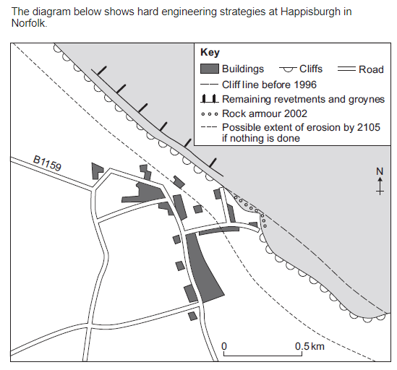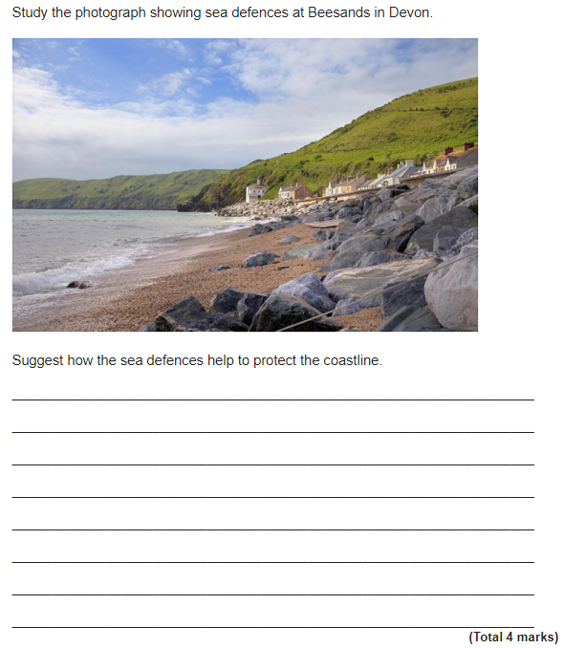

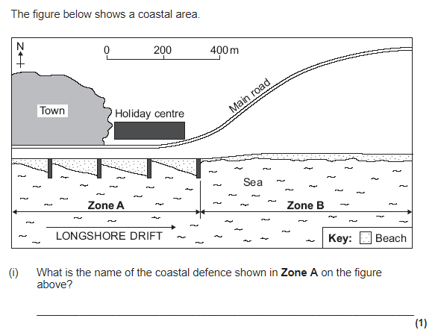

**Figure 3**

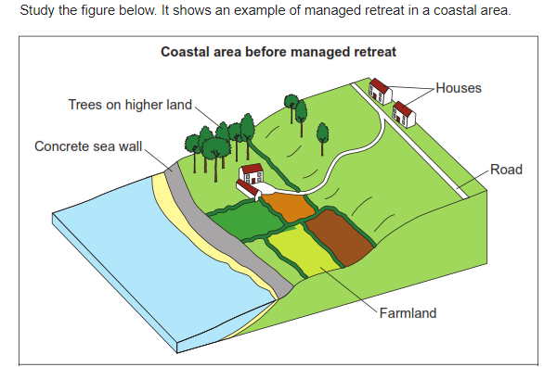

**Figure 4**

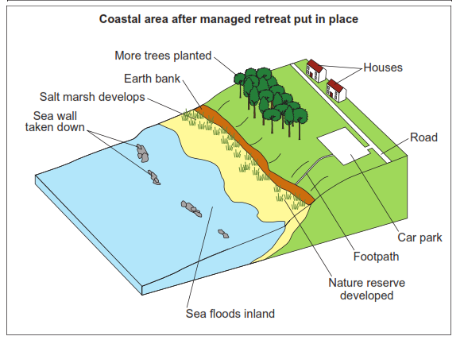

|  |  |  |  |  |
| --- | --- | --- | --- | --- |
| Physical Landscapes in the UK - Rivers Page 14 | | | | |
| Question | **A B C** | | | |
| 1. What is the water cycle? | | The movement of water from the source to the mouth | The movement of water around the earth. | The movement of water from water to a gas |
| 1. Define evaporation | | The sun heats up water. The ice melts into a gas which sinks into the atmosphere (air). | The sun heats up water. The water turns into a solid which rises up into the atmosphere (air). | The sun heats up water. The water turns into a gas which rises up into the atmosphere (air). |
| 1. Define transpiration | | The sun heats up water on the leaves of trees. The water turns into a gas which sinks to the ground. | The sun heats up water on the leaves of trees. The water turns into a gas which condenses up into the atmosphere (air). | The sun heats up water on the leaves of trees. The water turns into a gas which evaporates up into the atmosphere (air). |
| 1. Define infiltration | | When liquid is sucked up by a tree’s roots. | When liquid enters a rock | When liquid moves in a river channel |
| 1. Identify the process when water cools and forms clouds. | | Precipitation | Evaporation | Condensation |
| 1. What is the name of the start of a river? | | Source | Mouth | Tributary |
| 1. Name the point where the river meets the sea | | Confluence | Source | Mouth |
| 1. Name the point where two rivers meet | | Tributary | Confluence | Mouth |
| 1. Define the watershed | | The point where two rivers meet. | A stream or smaller river that joins a larger river. | The boundary of a drainage basin. It separates one drainage basin from another. |
| 1. What is a tributary | | A stream or smaller river that joins a larger river. | A point where two streams or rivers meet. | The point where the river meets the sea or ocean. |
| 1. Define surface run off | | When water enters a rock and flows through the rocks and soil underground. | When the water runs off the surface of the ground as a river or stream. | The evaporation of water from the leaves of trees. |
| 1. Identify the name of the area of land which drains into a specific river. | | Tributary | Watershed | Drainage basin |
| **RIVER PROFILE** | |  | | |
| 1. Define long profile. | | The gradient of a river from its source to its mouth. | The cross section of the river channel. | The shape of the river channel and river valley |
| 1. List the three courses of a river. | | Higher Middle Lower | Upper Middle Lower | Upper Lower Lowest |
| 1. How does the long profile of a river change in the upper and lower course? | | In the upper course the gradient is steep, whereas in the lower course it is more flat. | In the upper course the gradient is high, whereas in the lower course it is more medium. | In the upper course the gradient is flat, whereas in the lower course it is steep. |
| 1. Define cross profile. | | The gradient of a river from its source to its mouth. | The cross section of the river channel. | The speed of the water flow in each course of the river. |
| 1. Describe the cross profile of a river in the upper course. | | The river channel is narrow and shallow. The river valley is steep. | The river channel is deep and narrow and shallow. The river valley is steep. | The river channel is narrow and shallow. The river valley is gentle. |
| 1. Describe the cross profile of a river in the lower course. | | The river channel is wide and shallow. The river valley is steep. | The river channel is wide and deep. The river valley is steep. | The river channel is wide and deep. The river valley is flat. |
| **RIVER PROCESSES** | |  | | |
| 1. Define erosion | | Wearing away or breaking down of rocks by day-to-day changes in the atmosphere. | The wearing away and removal of rock by the river. | Wearing or breaking down of rocks by plants and animals. |
| 1. Describe the process of attrition. | | Sediment carried by the river repeatedly hits the river bed and banks. It acts like sandpaper removing material. | Stones carried by the river, hit into each other making the rocks bigger. | Stones carried by the river hit into each other, gradually making the rocks smaller and smoother. |
| 1. Define corrosion. | | Chemicals in the water that dissolve rocks | Stones carried by the river hit into each other, gradually making the rocks smaller and smoother. | Sediment carried by the river repeatedly hits the river bed and banks. It acts like sandpaper removing material. |
| 1. Define weathering. | | Wearing away or breaking down of rocks by day-to-day changes in the atmosphere. | The wearing away and removal of rock by the river. | Wearing or breaking down of rocks by plants and animals. |
| 1. Does freeze thaw weathering affect the river channel or river valley? | | River channel and the river valley | River channel | River valley |
| 1. Define transportation. | | The wearing away and removal of rock by the river. | Eroded materials carried by the river downstream | Material within the river (its load) it dropped. |
| 1. Identify three different types of transportation. | | Traction, suspension, saltation | Traction, corrosion, saltation | Traction, suspension, corrosion |
| 1. Suggest the size of material that is transported by saltation. | | Large pebbles | Fine sediment (e.g. alluvium) | Small pebbles |
| 1. Define traction | | Rocks and large pebbles roll along the river bed | Small pebbles bounce along the river bed. | Material is suspended within the water. |
| 1. Define deposition. | | The wearing away and removal of rock by the river. | Eroded materials carried by the river downstream | Material within the river (its load) it dropped. |
| 1. Give one reason why deposition will occur. | | The river loses energy | The river gains energy | The river flows more quickly. |
| 1. Suggest why smaller sediments are found in the lower course of the river, whereas large rocks are found in the upper course. | | Abrasion makes the rocks become small and smoother as they travel downstream | Attrition makes the rocks become smaller and smoother as they travel downstream. | Hydraulic action makes the rocks become smaller and smoother as they travel downstream. |

|  |
| --- |
| Physical Landscapes in the UK - Rivers Page 14 |
| Question |
| 1. What is the water cycle? |
| 1. Define evaporation |
| 1. Define transpiration |
| 1. Define infiltration |
| 1. Identify the process when water cools and forms clouds. |
| 1. What is the name of the start of a river? |
| 1. Name the point where the river meets the sea |
| 1. Name the point where two rivers meet |
| 1. Define the watershed |
| 1. What is a tributary |
| 1. Define surface run off |
| 1. Identify the name of the area of land which drains into a specific river. |
| **RIVER PROFILE** |
| 1. Define long profile. |
| 1. List the three courses of a river. |
| 1. How does the long profile of a river change in the upper and lower course? |
| 1. Define cross profile. |
| 1. Describe the cross profile of a river in the upper course. |
| 1. Describe the cross profile of a river in the lower course. |
| **RIVER PROCESSES** |
| 1. Define erosion |
| 1. Describe the process of attrition. |
| 1. Define corrosion. |
| 1. Define weathering. |
| 1. Does freeze thaw weathering affect the river channel or river valley? |
| 1. Define transportation. |
| 1. Identify three different types of transportation. |
| 1. Suggest the size of material that is transported by saltation. |
| 1. Define traction |
| 1. Define deposition. |
| 1. Give one reason why deposition will occur. |
| 1. Suggest why smaller sediments are found in the lower course of the river, whereas large rocks are found in the upper course. |

**PHYSICAL LANDSCAPES IN THE UK: RIVERS - PART 1 (page 14)**

Describe how water moves around the earth. (4 marks)

What is meant by the terms: watershed, drainage basin and confluence? (3 marks)

What is meant by the terms: source, mouth and tributary? (3 marks)

Study Figure 1, a diagram showing the long and two cross profiles of a river.

1. Describe the shape of the river’s long profile. (1 mark)
2. Describe the cross profile in the upper course of the river. (3 marks)
3. Describe the cross profile in the lower course of the river. (3 marks)
4. Explain why the cross profile or a river changes downstream (4 marks)
5. State one reason why the size of sediment carried by the river decreases downstream (1 mark)

Study Figure 2, a block diagram showing how river landforms change downstream.

1. Use the diagram to identify a landform found in the upper course, middle course and lower course. (3 marks)
2. With the help of the diagram, describe how the shape of a river valley changes downstream. (4 marks)

Figure 3 shows four ways in which a river transports its load.

1. Label the diagram. (4 marks)
2. Describe how a river transports its load. (4 marks)

Describe how a river erodes. (3 marks)

Explain why a river deposits its load. (2 marks)

Study Figure 4, a 1 : 50,000 Ordnance Survey map extract of part of the River Ouse.

1. State one characteristic of the course of the River Ouse in grid square 4754. (1 mark)
2. Give the difference in height between the river flood plain at 481561 and the spot height at 460563. (1 mark)

**Figure 1**

**Figure 2**

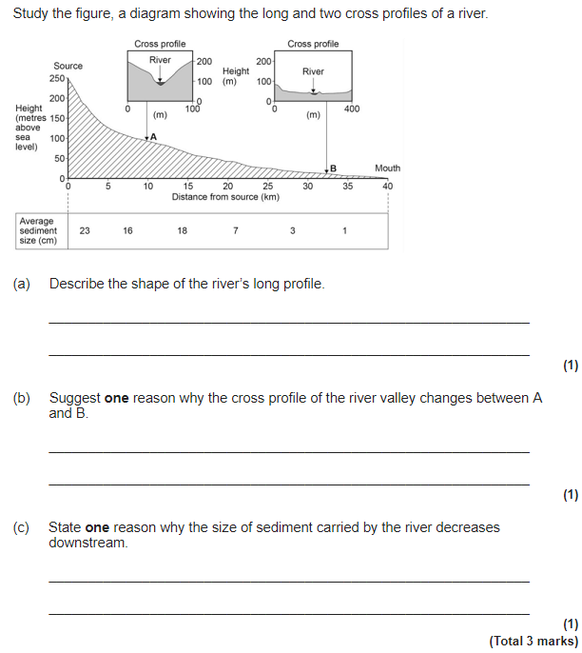

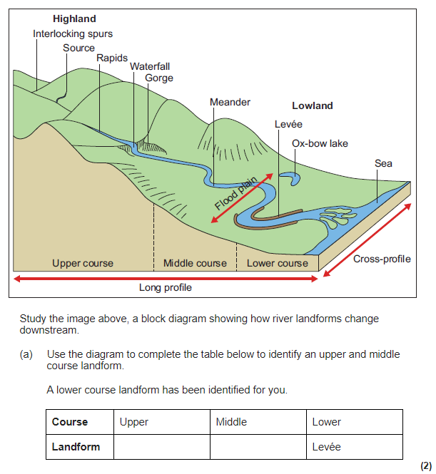

**Figure 4**

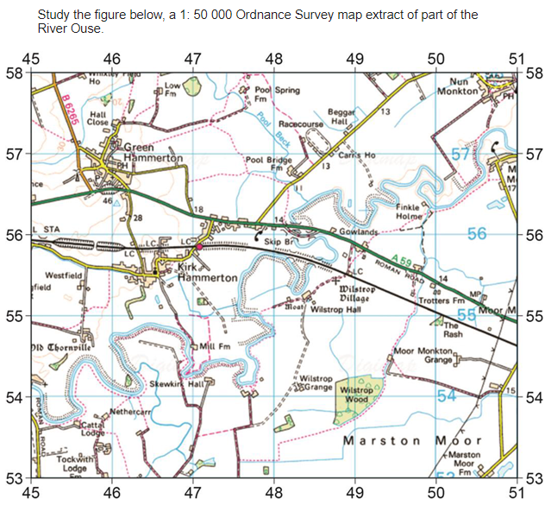

**Figure 3**

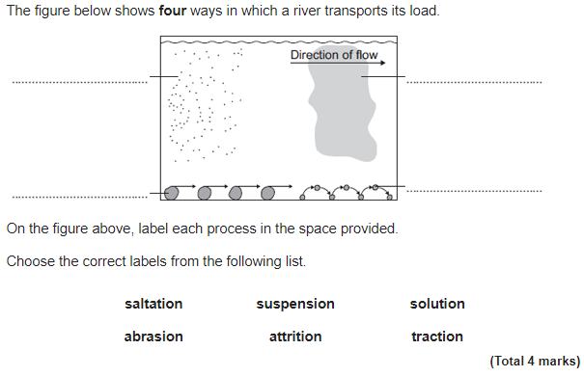

|  |  |  |  |  |
| --- | --- | --- | --- | --- |
| Physical Landscapes in the UK - Rivers Page 15 | | | | |
| Question | **A B C** | | | |
| **EROSIONAL LANDFORMS** | |  | | |
| 1. In what course of a river are erosional landforms created? | | Upper course | Middle course | Lower course |
| 1. In what erosional landform do you find an overhanging cliff and plunge pool. | | Interlocking spurs | Waterfall | Levee |
| 1. What is a gorge? | | A steep fall of water. | A raised river bed. | A narrow steep sided valley. |
| 1. Do you find lateral or vertical erosion in the upper course of a river? | | Lateral erosion | Vertical erosion | -- |
| 1. What conditions are necessary for a waterfall to form? | | Horizontal erosion | Hard rock overlying soft rock | Deposition |
| 1. As a waterfall retreats upstream, what erosional landform is formed? | | Gorge | Interlocking spurs | A floodplain |
| 1. Explain how interlocking spurs are formed. | | The water in the upper course is not powerful enough to erode laterally. As a result the water flows around bands of more resistant rock = interlocking spurs. | It is formed due to the gradual retreat of a waterfall over hundreds or thousands of years. | When rivers flood, the speed of water decreases = deposition. Heavier, more coarse material is deposited first. Over time this builds up. |
| 1. What does vertical erosion form? | | V-shape valleys | A levee | Waterfalls |
| **LANDFORMS FORMED BY EROSION & DEPOSITION** | |  | | |
| 1. Define meander. | | A wide, flat area of marshy land. | A bend in the river. | A U shaped lake. |
| 1. What processes occurs on the outside of a bend and why? | | Erosion due to the faster flow of water. | Deposition due to the slower flow of water. | Erosion due to the slower flow of water. |
| 1. What processes occurs on the inside of a bend and why? | | Erosion due to the faster flow of water. | Deposition due to the slower flow of water. | Erosion due to the slower flow of water. |
| 1. Define ox-bow lake. | | A U shaped lake formed when a meander is no longer connected to a river. | A bend in the river. | A wide, flat area of marshy land. |
| 1. Why does the neck of a meander eventually break through? | | Due to continued erosion on the outside of the bend and deposition on the inside of the bend. | Due to continued deposition on the outside of the bend and erosion on the inside of the bend. | Due to continued erosion on the inside of the bend and deposition on the outside of the bend. |
| 1. Why is an ox-bow lake eventually formed? | | The flow of water slows down = less energy = deposition occurs. This deposition eventually blocks off the meander = U shaped lake. | Vertical erosion creates steep sided valleys. Weathering of the river valley results in the formation of an ox-bow lake. | The soft rock is eroded more quickly than the hard rock. This creates a plunge pool and overhanging cliff. |
| **DEPOSITIONAL LANDFORMS** | |  | | |
| 1. Where do you find depositional landforms? | | Upper course | Middle course | Lower course |
| 1. What is a floodplain? | | A U shaped lake formed when a meander is no longer connected to a river. | A bend in the river. | A wide, flat area of marshy land on either side of a river. |
| 1. What causes silt to be repeatedly deposited? | | Increase in the speed of water flow. | Flooding | Erosion |
| 1. What is a levee? | | A raised river bed found alongside a river. | A bend in the river | A narrow steep sided valley. |
| 1. What material is deposited first, close to the river channel? | | Fine material, also known as alluvium or silt. | Heavier, more coarse material. | -- |
| 1. Where is silt deposited? | | On the outside bend of a river. | In the upper course of the river. | On the floodplain. |
| 1. What is an estuary? | | A raised river bed found alongside a river. | The wide part of a river near the mouth of a river. | A steep fall of water. |
| 1. Estuaries are formed in the transitional zone. What does this mean? | | Water flowing down the river, meets water flowing up the river from the sea. | Water flowing down the river meets up with a tributary. | Water flowing down the river meets up with middle and lower course before the sea. |
| 1. What often forms in estuaries? | | Waterfalls | Salt marshes | Gorges |
| **STORM HYDROGRAPH** | |  | | |
| 1. What is a storm hydrograph? | | A graph that shows the relationship between rainfall and lag time. | A graph that shows the relationship between rainfall and river discharge. | A graph that shows the relationship between rising limb and river discharge. |
| 1. Define river discharge. | | The volume of water in a river channel. | The time between peak rainfall and peak discharge | The amount of water that floods over the river channel |
| 1. Give the name for the time between the peak rainfall and peak discharge | | Storm hydrograph | Lag time | Falling limb |
| 1. If there is a short lag time what does this mean? | | -- | There is a greater risk of flooding. | There is a reduced risk of flooding |
| 1. Identify one physical factor that increases the risk of flooding. | | Heavy, intense rainfall | Permeable rock | Urbanisation |
| 1. Identify one human factor that increases the risk of flooding. | | Permeable rock | Urbanisation | Afforestation |
| 1. Identify one physical factor that reduces the risk of flooding. | | Gentle gradient | Impermeable rock | Urbanisation |
| 1. Identify one human factor that reduces the risk of flooding. | | Impermeable rock | Steep gradient | Afforestation |

|  |
| --- |
| Physical Landscapes in the UK - Rivers Page 15 |
| Question |
| **EROSIONAL LANDFORMS** |
| 1. In what course of a river are erosional landforms created? |
| 1. In what erosional landform do you find an overhanging cliff and plunge pool. |
| 1. What is a gorge? |
| 1. Do you find lateral or vertical erosion in the upper course of a river? |
| 1. What conditions are necessary for a waterfall to form? |
| 1. As a waterfall retreats upstream, what erosional landform is formed? |
| 1. Explain how interlocking spurs are formed. |
| 1. What does vertical erosion form? |
| **LANDFORMS FORMED BY EROSION & DEPOSITION** |
| 1. Define meander. |
| 1. What processes occurs on the outside of a bend and why? |
| 1. What processes occurs on the inside of a bend and why? |
| 1. Define ox-bow lake. |
| 1. Why does the neck of a meander eventually break through? |
| 1. Why is an ox-bow lake eventually formed? |
| **DEPOSITIONAL LANDFORMS** |
| 1. Where do you find depositional landforms? |
| 1. What is a floodplain? |
| 1. What causes silt to be repeatedly deposited? |
| 1. What is a levee? |
| 1. What material is deposited first, close to the river channel? |
| 1. Where is silt deposited? |
| 1. What is an estuary? |
| 1. Estuaries are formed in the transitional zone. What does this mean? |
| 1. What often forms in estuaries? |
| **STORM HYDROGRAPH** |
| 1. What is a storm hydrograph? |
| 1. Define river discharge. |
| 1. Give the name for the time between the peak rainfall and peak discharge |
| 1. If there is a short lag time what does this mean? |
| 1. Identify one physical factor that increases the risk of flooding. |
| 1. Identify one human factor that increases the risk of flooding. |
| 1. Identify one physical factor that reduces the risk of flooding. |
| 1. Identify one human factor that reduces the risk of flooding. |

**PHYSICAL LANDSCAPES IN THE UK: RIVERS - PART 2 (page 15)**

Study Figure 1, a photograph showing the waterfall at High Force on the River Tees. Using the photograph, explain the processes involved in the formation of the landforms shown. (6 marks)

Study Figure 2, a photograph of the Rio Grande Gorge. Figure 3 is a black and white copy of Figure 2.

1. Label the characteristics of the river and the valley shown at X, Y and Z. (3 marks)

Figure 3 shows the formation of a gorge. Use the diagrams and your own knowledge to explain the formation of a gorge. (6 marks)

Study Figure 4, a photograph of a waterfall in the Glens of Antrim, Northern Ireland. Describe the features of the waterfall shown in the figure. (3 marks)

Study Figure 5, a photograph of the River Tees in its middle course.

1. Identify three characteristics of the channel and valley in the middle course of the river. (3 marks)
2. Explain the formation of a meander. (4 marks)

Draw a labelled cross-section to show how the inside bend of a meander is different from the outside bend of a meander. (4 marks)

Explain the formation of an ox-bow lake. (4 marks)

Study Figure 6, a diagram showing some features of the lower course of a river.

1. Identify three features of the lower course of a river.
2. A levee is shown in the diagram. What are levees? (2 marks)
3. Explain, with the aid of a diagram(s), how levees are formed. You must use the following key words: *deposition, floods, build-up of layers, loss of energy*. (6 marks)

Choose one of the following landforms and explain its formation: *estuary or floodplain*. (4 marks)

Study Figure 7, a sketch hydrograph of a river flowing through a forest after a period of rain. A hydrograph shows the link between rainfall and discharge in a river.

1. What is meant by the term river discharge? (1 mark)
2. What is meant by the term lag time? (1 mark)
3. How would a hydrograph look different for a river flowing through a deforested area in the same period of rain? (3 marks)
4. Explain the factors that affect river discharge. (6 marks)

**Figure 2**

**Figure 1**

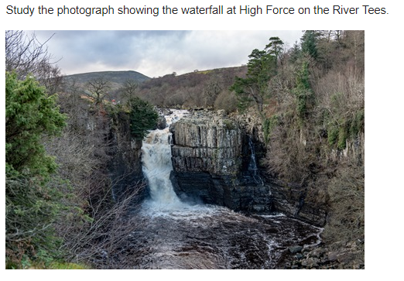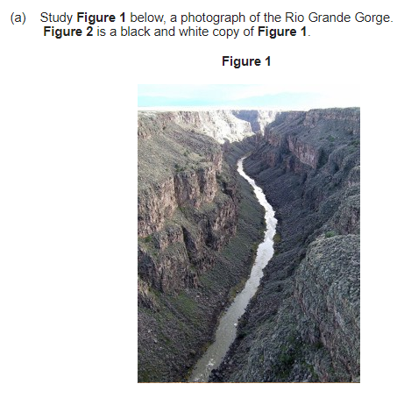

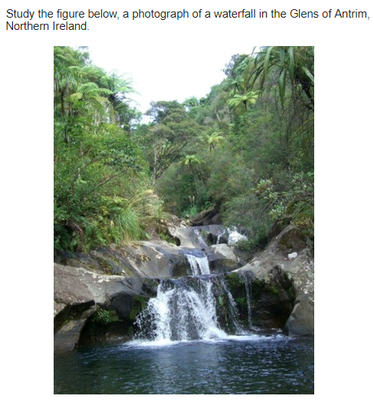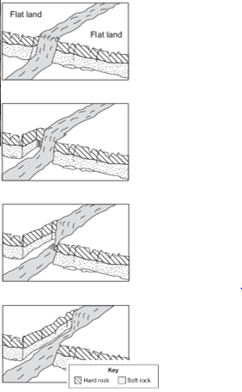

**Figure 3**

**Figure 4**

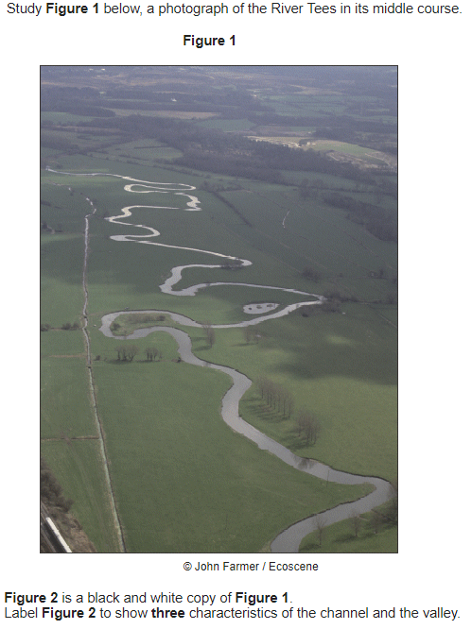

**Figure 5**

**Figure 6**

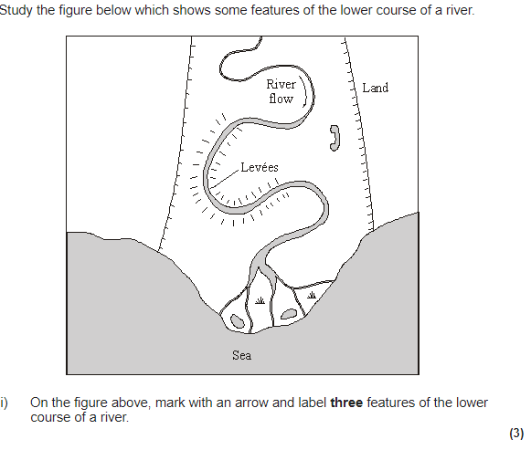

**Figure 7**

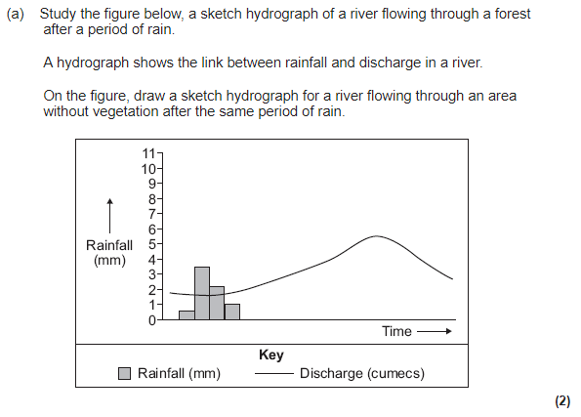

|  |  |  |  |  |
| --- | --- | --- | --- | --- |
| Physical Landscapes – Rivers Page 16 | | | | |
| Question | **A B C** | | | |
| **HARD ENGINEERING** | |  | | |
| 1. Define hard engineering. | | Using manmade artificial structures to prevent flooding. | Using natural, environmentally friendly methods to prevent flooding. | -- |
| 1. Identify one benefit of using hard engineering over soft engineering. | | It has a shorter lifespan | It is more effective. | It is less expensive |
| 1. What is a dam and reservoir and how can it prevent flooding? | | It is a concrete wall built across the river to redirect water into another river. This means eventually water will dry up further down the river. | It is a concrete wall that stops water flowing back upwards towards the river source. This prevents flooding by reducing the amount of water in the river. | It is a concrete wall built across a river that prevents water flow. This results in the creation of a lake known as a reservoir. The flow of water can be regulated by being turned off during heavy rainfall. This prevents too much water entering the river. |
| 1. What is channel straightening and how does it prevent flooding? | | Rivers are straightened by cutting through meanders to create a straight channel. Therefore water travels faster down the river and doesn’t have time to build up. | A man-made river channel constructed to divert water in a river channel away from urban areas. | Used to regulate river flow and reduce the risk of flooding. The flow of water can be ‘turned off’ during periods of heavy rainfall. The water is stored in a reservoir so that the river does not flood downstream. |
| 1. What is the strategy where the banks of a river are raised? | | River restoration | Embankment | Wetlands |
| 1. What is a flood relief channel? | | A raised riverbank (levee) which allows the river channel to hold more water | Rivers are straightened by cutting through meanders to create a straight river channel. This speeds up the flow of water along the river. | A man-made river channel constructed to divert the flow of water, away from urban areas. |
| 1. Suggest one advantage of using embankments. | | They educate people what to do during a flood. | They effectively prevent floods from occurring | They are expensive. |
| 1. Suggest one disadvantage of using channel straightening for settlements downstream. | | The faster flow of water results in less flowing downstream | The slower flow of water results in flooding downstream. | The faster flow of water results in flooding downstream. |
| **SOFT ENGINEERING** | |  |  |  |
| 1. Define soft engineering | | Using manmade artificial structures to prevent flooding. | Using natural, environmentally friendly methods to prevent flooding. | -- |
| 1. Identify one benefit of using soft engineering over hard engineering. | | It is more effective at preventing flooding | It is more natural and less harmful to wildlife. | It is more expensive. |
| 1. How does floodplain zoning reduce the cost of flooding? | | Land closest to the river is used for parkland, whereas land further from the river is used for housing/industries = high value land is protected as it is further from the river | Land closest to the river is used to grow extra trees. This land is flooded so the flood water will be intercepted meaning the river discharge decreases. | Rivers are monitored to measure flood risk using satellites, instruments and computer models. The Environmental Agency issue alarms if a flood will happen |
| 1. Suggest the term given to planting trees to absorb water. | | Wetlands | Afforestation | Floodplain zoning |
| 1. Suggest one way people can protect their homes. | | Build their homes in low lying areas. | Place sandbags around their home | Ensure their valuables are on the ground floor. |
| 1. What is a wetland? | | Land is allocated for different uses, with high value land created further from a river. | Returning a river to its natural state. | Land next to the river that is left to flood. |
| 1. How can wetlands prevent flooding downstream? | | Rivers are monitored to measure flood risk using satellites, instruments and computer models. The Environmental Agency issue alarms if a flood will happen | Excess water is stored in the lake created by the flooded land = less is in the river channel. | Land closest to the river is used for parkland, whereas land further from the river is used for housing/industries = high value land is protected as it is further from the river |
| 1. Which strategies reduce the risk of flooding? | | Afforestation and wetlands | Afforestation and floodplain zoning | Wetlands and river restoration. |
| 1. Which strategies help people to prepare of a flood when it occurs? | | Floodplain zoning and wetlands | River restoration and afforestation | Floodplain zoning and planning/preparation |
| **SOMERSET FLOODS** | |  | | |
| 1. Where is Somerset? | | South-west England | South-east England | Central England |
| 1. When did the flood occur? | | January & March 2014 | February & March 2014 | January & February 2014 |
| 1. How much rain fell in January & February? | | 350mm | 250mm | 450mm |
| 1. List one other cause of the flood. | | The rivers had not been dredged in 20 years | High tides & storm surges | Both A and B. |
| 1. List two social effects of the flood. | | 600 homes were flooded and it cost Somerset Council £10 million. | 600 homes were flooded and villages were cut off | Floodwater containing sewage flooded farmland and villages were cut off. |
| 1. List two economic effect of the flood. | | 14,000 hectares of agricultural land flooded and it cost Somerset Council £10 million | Power supplies were cut off and local railway lines needed fixing. | It cost £10,000 and 16 farms were evacuated. |
| 1. List one environmental effect of the flood. | | It cost Somerset Council £10 million | 600 homes were flooded. | Floodwater containing sewage contaminated farmland |
| 1. What is dredging? | | Raising the banks of the rivers. | Adding sediment to a river channel to make it larger | Removing sediment from river channels to make them larger |
| 1. What did they do to the river banks? | | Remove sediment from the banks to make them level | Raised them to create embankments | Dig ditches either side of the rivers. |
| 1. How did they prevent transport routes being affected by future floods? | | Elevated roads | Lowered roads | Covered roads in a waterproof plastic. |
| 1. How did they help people plan for future floods? | | Elevated roads | Dredged the rivers | Gave them flood defences (e.g. sandbags) |

|  |
| --- |
| Physical Landscapes in the UK - Rivers Page 16 |
| Question |
| **HARD ENGINEERING** |
| 1. Define hard engineering. |
| 1. Identify one benefit of using hard engineering over soft engineering. |
| 1. What is a dam and reservoir and how can it prevent flooding? |
| 1. What is channel straightening and how does it prevent flooding? |
| 1. What is the strategy where the banks of a river are raised? |
| 1. What is a flood relief channel? |
| 1. Suggest one advantage of using embankments. |
| 1. Suggest one disadvantage of using channel straightening for settlements downstream. |
| **SOFT ENGINEERING** |
| 1. Define soft engineering |
| 1. Identify one benefit of using soft engineering over hard engineering. |
| 1. How does floodplain zoning reduce the risks of flooding? |
| 1. Suggest the term given to planting trees to absorb water. |
| 1. Suggest one way people can protect their homes. |
| 1. What is a wetland? |
| 1. How can wetlands prevent flooding downstream? |
| 1. Which strategies reduce the risk of flooding? |
| 1. Which strategies help people to prepare for a future flood when it occurs? |
| **SOMERSET FLOODS** |
| 1. Where is Somerset? |
| 1. When did the flood occur? |
| 1. How much rain fell in January & February? |
| 1. List one other cause of the flood. |
| 1. List two social effects of the flood. |
| 1. List two economic effect of the flood. |
| 1. List one environmental effect of the flood. |
| 1. Identify one response by the Somerset county council to the Somerset floods |
| 1. What is dredging? |
| 1. What did they do to the river banks? |
| 1. How did they prevent transport routes being affected by future floods? |
| 1. How did they help people plan for future floods? |

**PHYSICAL LANDSCAPES IN THE UK: RIVERS - PART 3 (page 16)**

What is river flooding? (2 marks)

Study 2, a map showing the locations of flood events in England between 2000 and 2007.

1. Describe the locations of the flood events shown in the figure. (4 marks)
2. Use a case study to describe the social, economic and environmental impacts of a flood you have studied. (8 marks)

Study Figure 3, newspaper cuttings about the causes of flooding.

1. Using the figure only, give one physical cause and one human cause of flooding. (2 marks)
2. Use the figure and your own knowledge to explain why rivers flood. (6 marks)

Study Figure 1, a photograph showing the effects of river flooding in Somerset in 2014. Explain the likely economic effects of river flooding on the area shown in the photograph. (4 marks)

Describe and explain how people manage rivers to reduce the risk of flooding. (6 marks)

Study Figure 4, a photograph showing an information board describing flood management in Boscastle, Cornwall.

1. Give one example of hard engineering and one example of soft engineering shown in the photograph. (2 marks)
2. With the help of the photography, explain how hard and soft engineering strategies help to manage the risk of flooding in areas such as Boscastle. (8 marks)

Hard and soft engineering strategies are used to manage flooding. Choose either hard engineering or soft engineering and explain why it is the better strategy. (8 marks)

Discuss the effectiveness of hard engineering strategies to reduce the risk of flooding. (6 marks)

Discuss the effectiveness of soft engineering strategies to reduce the risk of flooding. (6 marks)

**Figure 1**

**Figure 2**

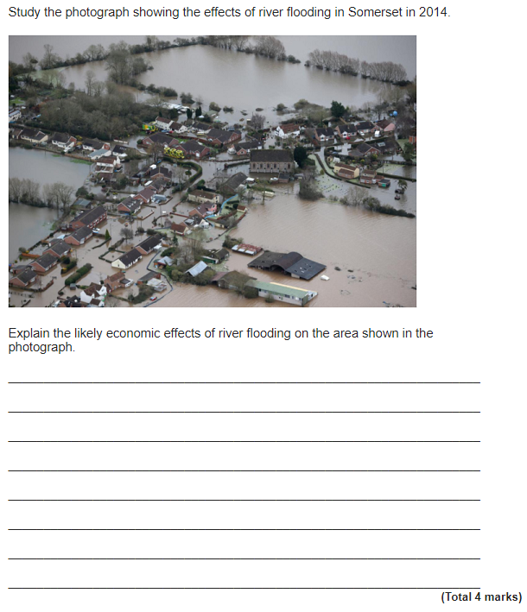

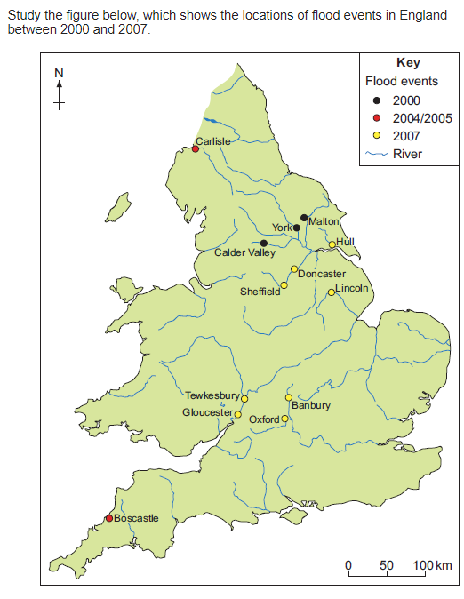

**Figure 3**

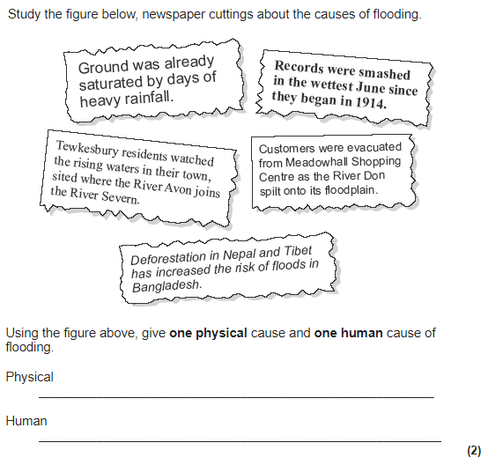

**Figure 4**

